The RTC Roadmap brings a wealth of information together in one place to help new and veteran Renton Technical College employees navigate the organization. Some of the items included in the Roadmap are:

* RTC mission and values
* Phone and SCAN system instructions
* Directory of employees by department and name
* Functional directory
* College services available to employees
* Campus map
* Computer use guidelines
* Part-time Faculty Information

This edition was revised and printed in September, 2009. Between annual editions, updated information is available on the RTC Shared Drive at T:\ SHARED\HR Forms\Roadmap.

Personnel information is updated by Human Resource Development 235-2296.

Please make suggestions regarding inclusion of additional features to Instructional Improvement x5750.

xz2otrya%5b1%5d

TABLE OF CONTENTS

Academic Dishonesty and Classroom Conduct 43

Administration /Executive Staff 21

Administrative Assistants 43

Adult Basic Education 43

Advisory Committees 44

All-USA Academic Team 44

Allied Health 23, 44

Apprenticeship 44

Apprenticeship Programs Directory 33

Associations/Unions 35

Auto Parts – Auto Repair 23, 44

Back-to-Industry 45

Bakery 45

Basic Studies 23, 45

Benefits – Full-Time employees 46

Board of Trustees 46

Bookstore 23, 46

Business Office 24, 46

Calendar /12 Month Employee 8

Calendar / Instructional 9

Campus Guide 6

CBE (Competency-Based Education) 47

Certificates 47

Certification for Instructors 47

Child Care Center 24, 47

Committees 48

Community Education 48

Computer Acceptable Use Policy 20  
Computer Labs 48

Construction Center of Excellence 24

Contract Training 49

Copiers 49

Copyright 49

Counseling 49, 50

Culinary Arts/Food Services 50

Curriculum 50

Custodians 25

Deans 51

Deans and Deans Assistants 22

Dental Clinic 51

Department Directory 21- 32

Direct Deposit 51

Directory by Name, Phone Ext, Mailbox No, and Room No 36 -42

eLearning 52

Email Addresses 19

Emergencies 52

Emergency Instructions for Inclement Weather 52- 53

Employment Security 53

English as a Second Language (ESL) 54

Executive Assistants 54

Executive Cabinet 54

External Diploma Program (EDP) 54

Facilities 25, 54

Fax Services 55

Field Trips 55

Financial Aid 25, 55

First Aid Classes 55

Food Services 26, 56

Foundation 56

Full-Time Faculty Directory 30 - 32

GED 56

General Education 56

Grading 57

Graphic Design 57

Grounds 26

Human Resource Development 26, 57

In case of emergency form 71

Information Services 27, 58

Information Technology Advisory 58

Instruction 27, 59

Instructional Computers 59- 61

Instructional Improvement 61

Job Service Center 62

Keys 62

Library 27, 62

Massage Therapy Clinic 63

Media Assistance and Set Up 63

Mission/Vision/Values Statement 5

Night Manager 63

Parking 63

Payroll 63, 64

Photocopying 64

PIN Number 64

President 21, 64

Privacy 65

Print Shop 27, 65

Procedures 65

Public Safety & Security 66

Recycling 66

Registration 28, 66

Research and Development 28, 67

Running Start 67

Satellite Office Locations 34

Safety & Health Committee 67

Security and Safety 28, 67

Student Services/Counseling 28-29

Student Success Center 68

Supplies 68

Tech Prep 68

Technology 68

Telephone Assistance 10-18

Telephones 68

Tenure and Tenure Committees 68

Testing Center 29, 68

Textbooks 69

Trade & Industry 69

Trade & Industry and Apprenticeship 69

Travel 69

Vehicle Requisition 69

Vending Machines... 7

Vice Presidents 69

Voice Mail 11 - 16

Website for RTC 70

Workforce Development 29, 70

Work-Study Program 70

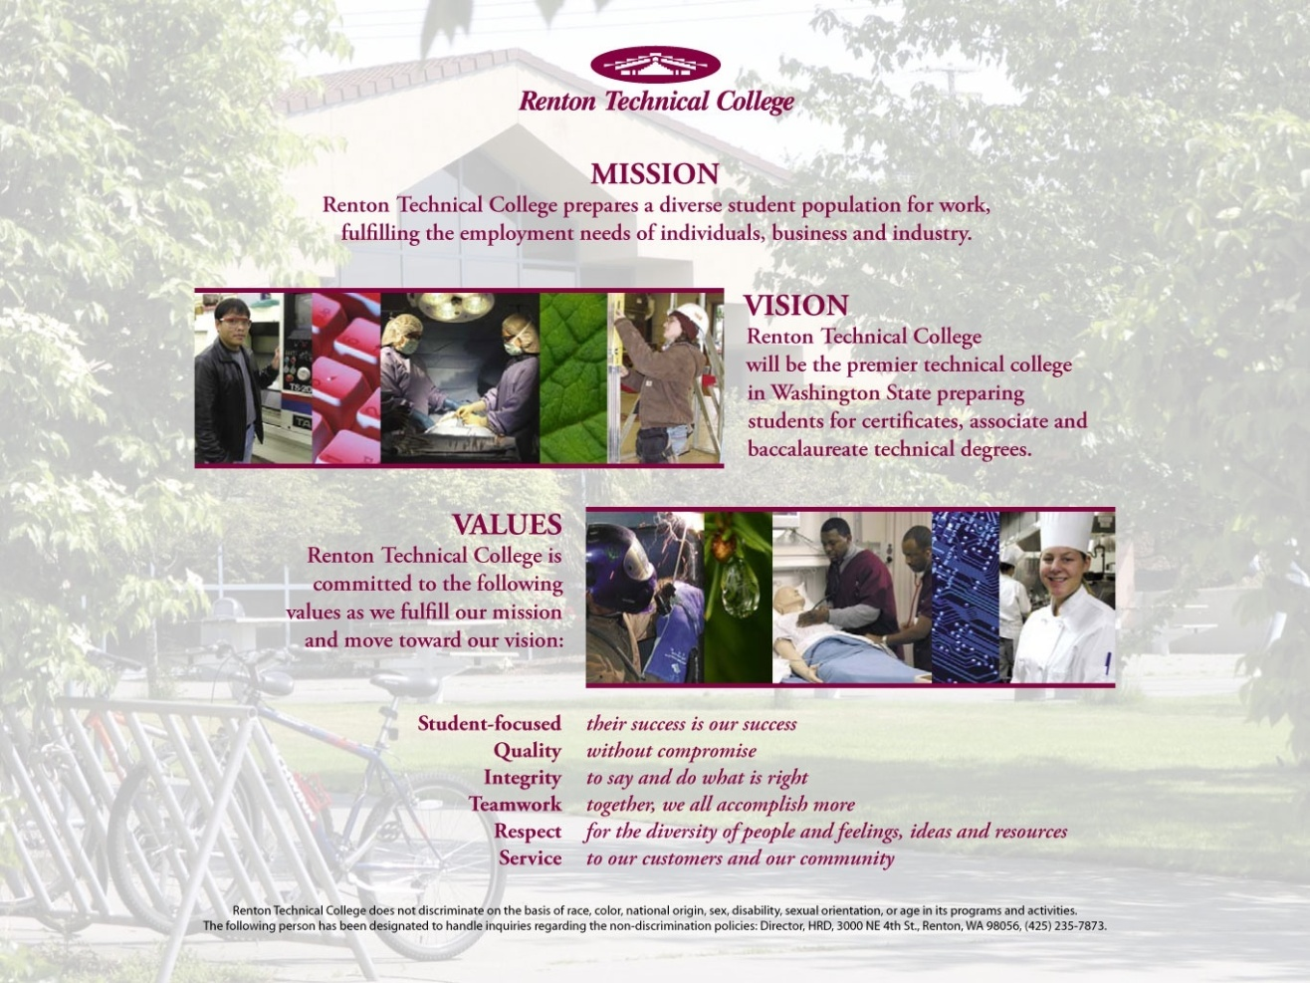

Our Mission

Renton Technical College prepares a diverse student population for work, fulfilling the employment needs of individuals, business and industry.

Our Mission for Diversity

Renton Technical College seeks to create a healthy, positive, respectful environment where the many voices of our students, faculty, and staff are heard and valued. The RTC community will accomplish this through awareness and the ongoing development of the knowledge and skills necessary to learn, work, and thrive in a diverse community.

Our Vision

Renton Technical College will be the premier technical college in Washington State preparing students for certificates, associate and baccalaureate technical degrees.

Our Values

Renton Technical College is committed to the following values as we fulfill our mission and move towards our vision:

**Student-Focused** *their success is our success*

**Quality** *without compromise*

**Integrity** *to say and do what is right*

**Teamwork** *together, we all accomplish more*

**Respect** *for the diversity of people and feelings, ideas and resources*

**Service** *to our customers and our community*

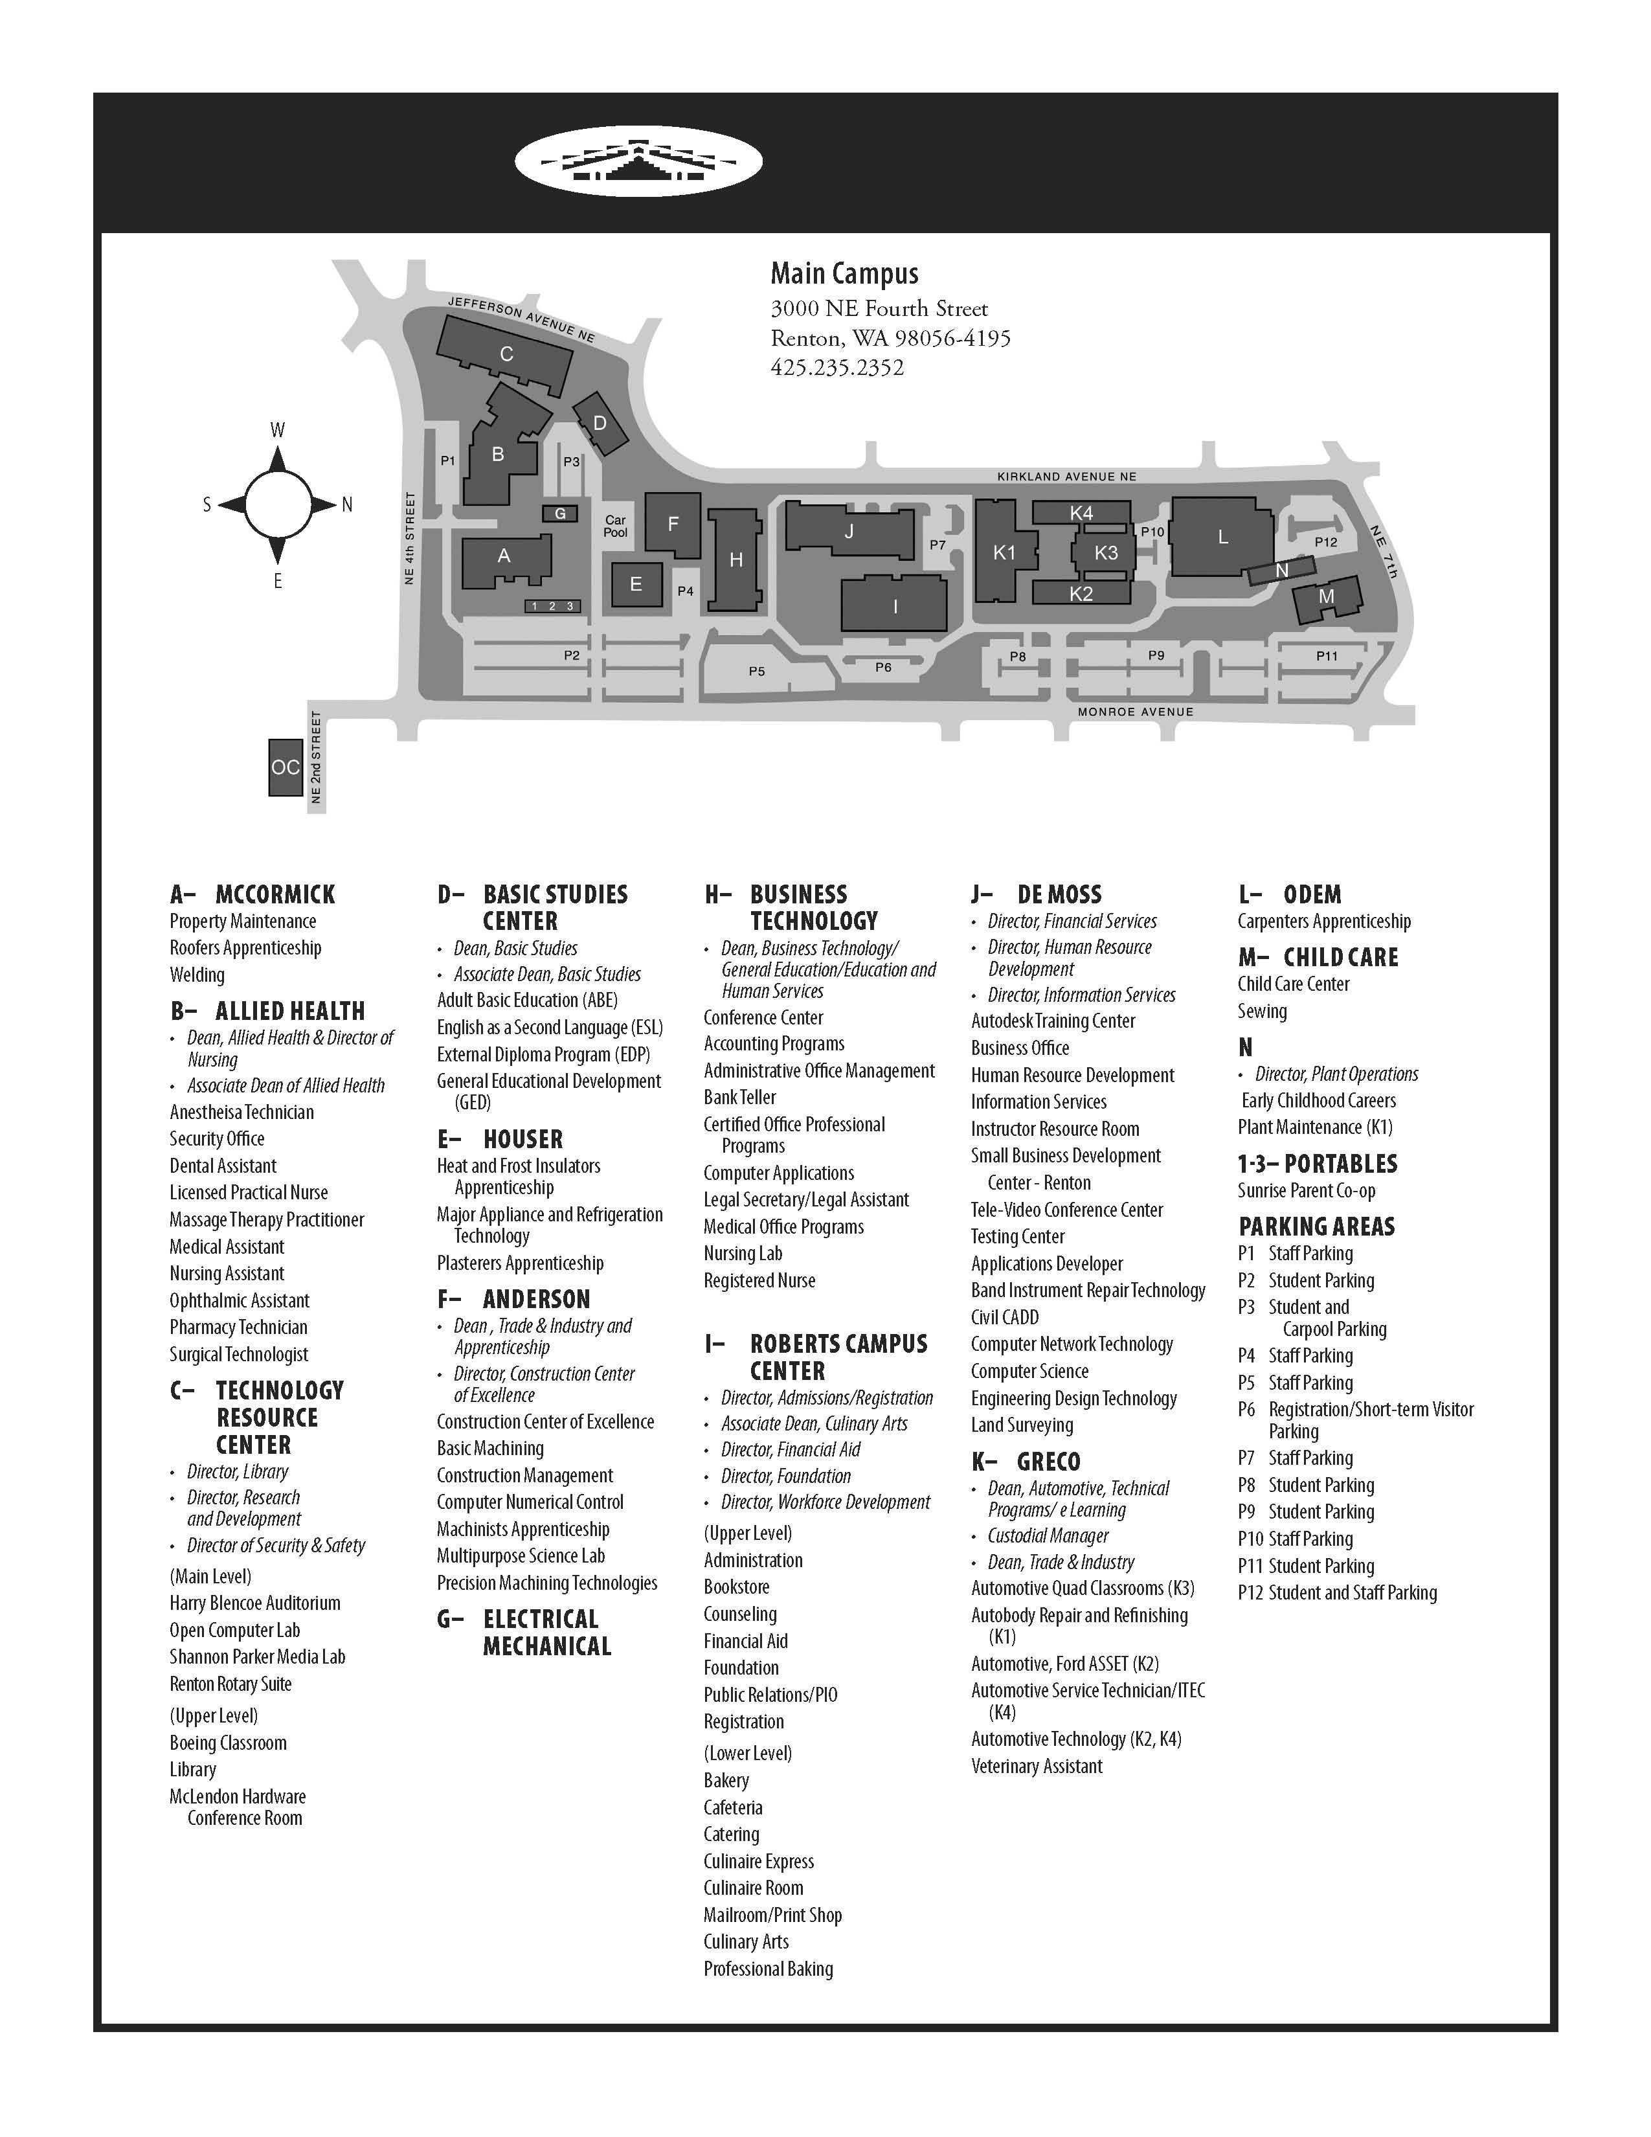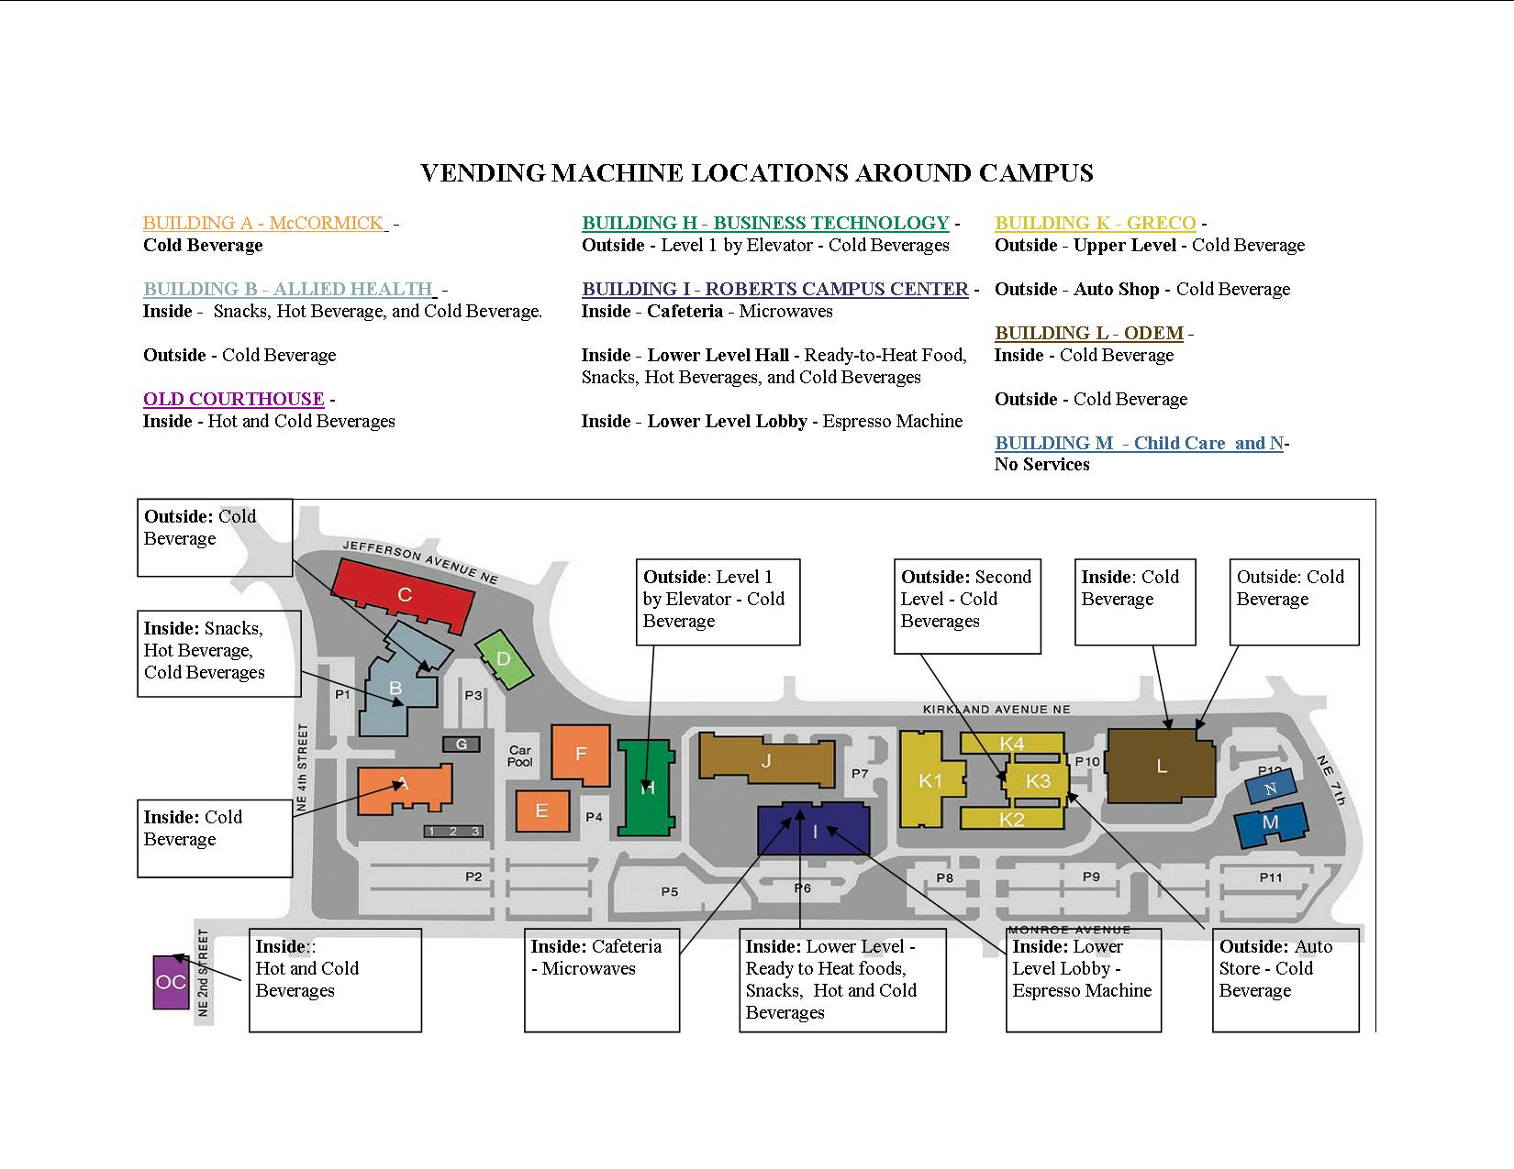

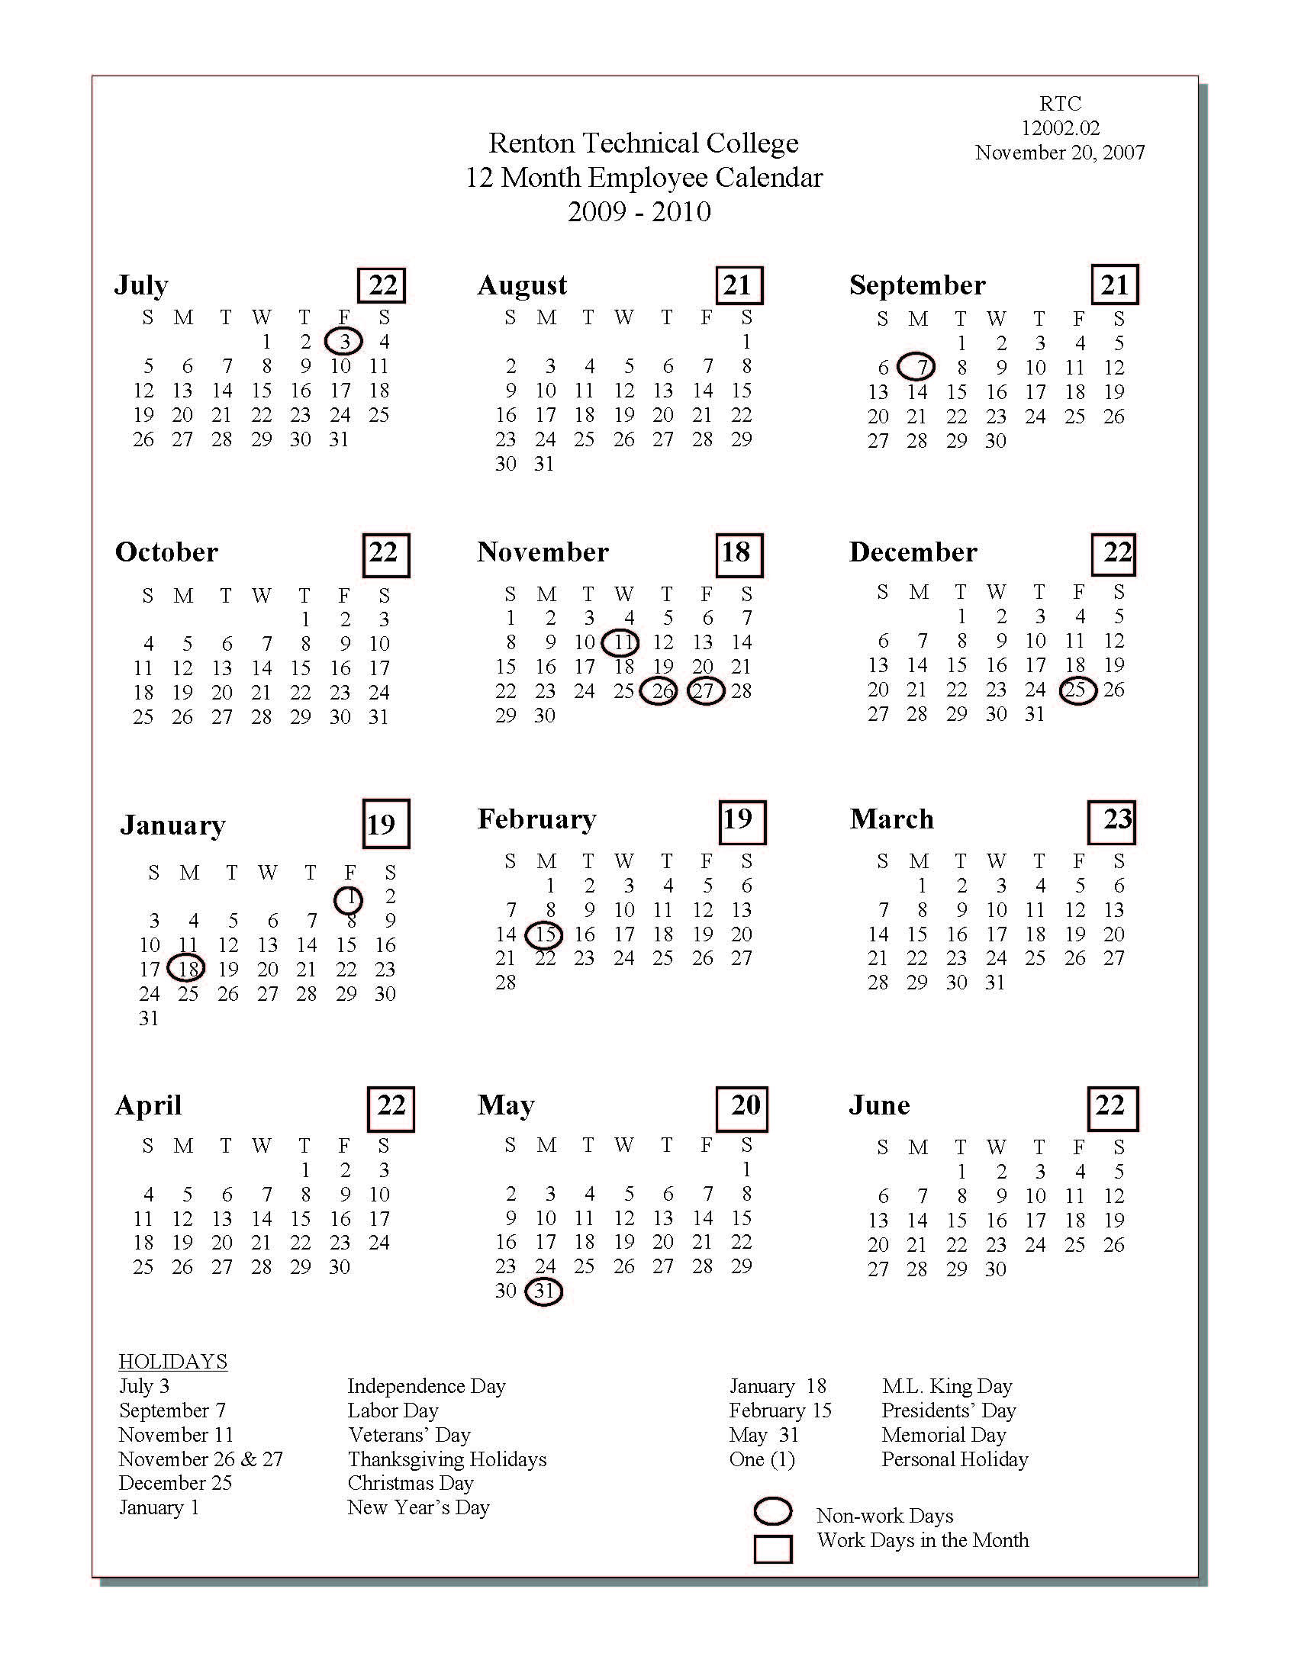

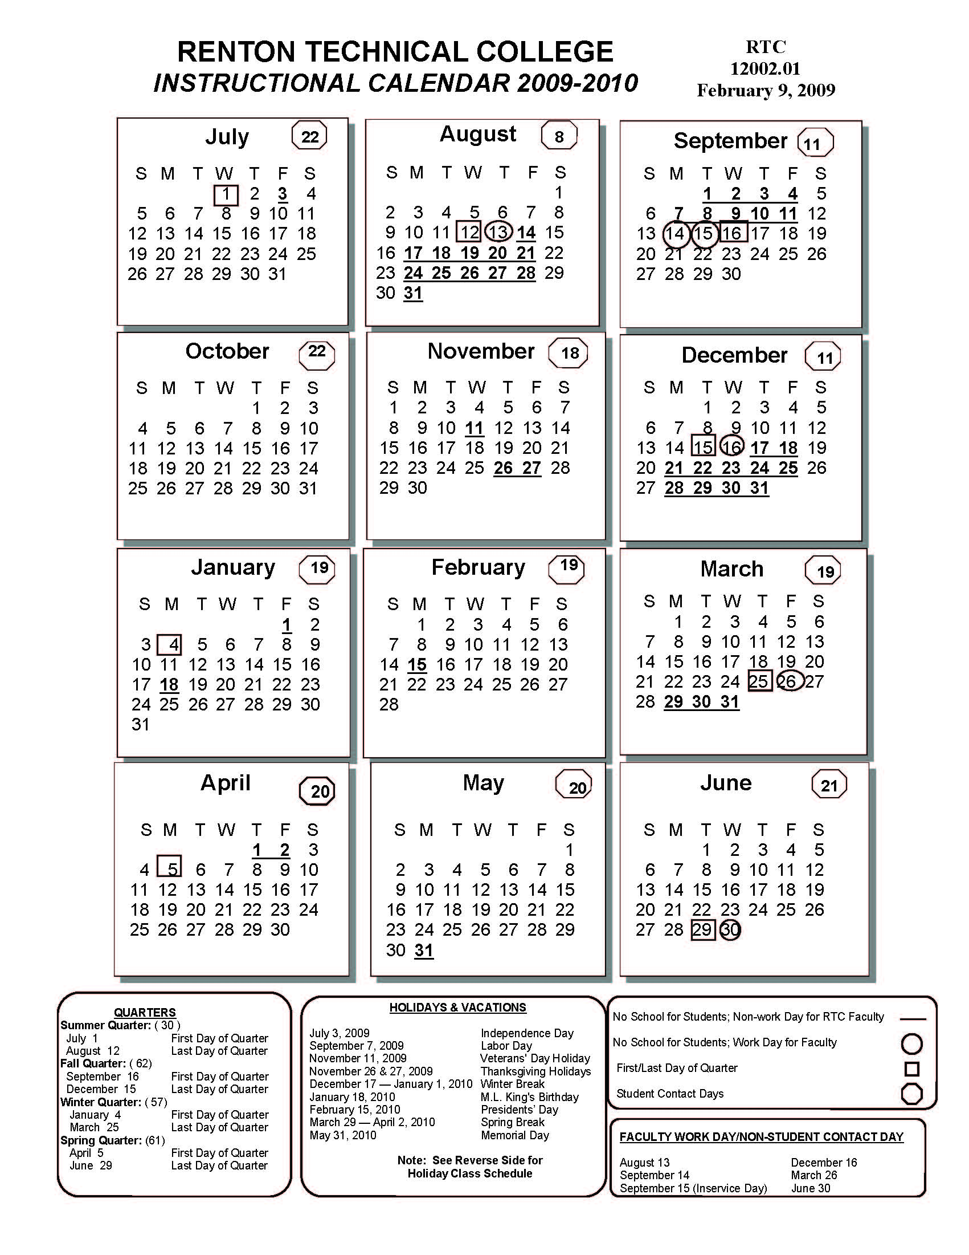

*TELEPHONE ASSISTANCE*

***The main line number for the college is 425-235-2352.***

**To check your voicemail from a phone other than those at the college, dial**

**425-235-2353, and follow the automated instructions.**

**SCAN**

To access the SCAN long distance telephone system, dial as follows:

*If your scan code is 6 digits:*

*8 + area code + 7 digit telephone number + 3 + (your 6 digit SCAN code)*

*If your scan code is 7 digits:*

*8 + area code + 7 digit telephone number + (your 7 digit SCAN code)*

**For additional information regarding scan numbers contact Iulia Zavodov (425-235-2352 x 5505)**

**Inclement Weather**

To obtain information regarding possible college closures due to inclement weather, dial (425)235-2352, extension 9. Or check our web site: [www.RTC.edu](http://www.RTC.edu)

**Driving Directions**

To obtain driving directions to the college, dial (425)235-2352, extension 8.

Or check our web site: http://www.rtc.edu/ContactUs/Map/

**HOW TO LOG IN TO VOICEMAIL**

**FOR THE FIRST TIME**

* Press the Voicemail button or enter extension *2353*.   
  If calling from outside the campus, dial (425) 235-2353.
* Enter your extension number followed by the # sign.   
  (***NOTE:*** If calling from the extension you are setting up, you can merely hit # - it will automatically use the extension number you are calling from.)
* Enter the temporary password *1397* followed by the # sign.   
  (***NOTE:*** You must use this temporary password the first time or the system will not allow you to log in.)

Once you have logged in, the system will ask you to do two things:

1. **Record Your Name**

Press 1 and speak your name. Press 1 when you are done. Listen to the play-back and press 1 to re-record or press # to approve.

1. **Create a New Password**

Enter a new password of four (4) to fifteen (15) digits, followed by the # sign. (It cannot be consecutive i.e., 123, ABC, etc.) Re-enter your new password followed by the # sign.

***FOR SECURITY REASONS, PLEASE CREATE A PASSWORD YOU CAN REMEMBER, BUT IS NOT TOO EASY.***

*Once you have initialized your mailbox, you will hear the Activity Menu with options to record messages, retrieve your messages and create personal greetings. You are now ready to use your new mailbox.*

**AUDIx User Instructions**

***Log In***

* Press the Voice Mail button OR enter ext. 2353.
* From outside the campus, dial 425-235-2353.
* Enter your extension followed by the # sign. (If calling from your own desk, just press #).
* Enter your password followed by the # sign.

**The first 3 items of the ACTIVITY MENU will repeat Every Time you log in:**

|  |
| --- |
| **ACTIVITY MENU**  Press 1 to record and send messages  Press 2 to get your messages  Press 3 to create your personal greeting  These are available but not repeated:  Press 4 to check outgoing messages  Press 5 to change password/re-record name  Press 6 to scan messages quickly |

***Sending Messages***

* LOG IN  
  Press 1 at the Activity Menu
* Speak your message
* Press 1 to edit this message

Press 2 then 3 to play back

Press *D to delete

* Press # to approve this message
* Enter the extension number followed by the # sign for each mailbox who is to receive this message. (If you make a mistake, press *D to delete that extension number.) If you are sending this message to a mailing list, press *L instead of an extension number. When you are finished addressing, press the # sign.
* Press # sign to send this message

OR

* Press 0 to listen to delivery options

Press 1 to send private

Press 2 to send priority (if available)

Press 3 to schedule delivery

Press 4 to file a copy

Press # to send this message

***Getting Messages***

* LOG IN
* Press 2 at the Activity Menu
* (Message summary – header – will play)
* Press 0 to listen to message
* (Message will play)
* During or after listening to this message:

Press # to save this message and skip to the next header

Press *D to delete message (will skip to the next header)

Press 1 to respond/forward this message; THEN press

2 to forward message to another mailbox

7 to reply to message (without copy)

[Audix will not prompt you for this option]

1 to reply to message (with copy)

0 to call sender back

***Play Back Controls***

While listening to your messages:

Press 3 to pause then 3 again to resume

4 to make louder

5 to back up (in 4-second increments)

6 to advance (in 4-second increments)

7 to make softer

8 to make slower

9 to make faster

0 to replay message

***Creating Greetings***

* LOG IN
* Press 3 at Activity Menu
* Press 1 to create or change this greeting
* Enter greeting number (1-9)
* Speak your greeting
* Press 1 to stop recording and edit this greeting
* Press 2 then 3 to play back
* Press *D to delete this greeting
* Press # sign to approve
* Press 1 to activate this greeting to replace the system greeting. (If you are changing this greeting or recording another greeting, this step is not necessary.)

***To Activate a Greeting***

* LOG IN
* Press 3 at the Activity Menu
* Press 3 to Activate a greeting
* Enter greeting number (1-9)
* This will activate a previously recorded greeting and put the former greeting in storage until you need it again.

***Once you Reach a Greeting***

Press 1 to bypass greeting (leave your message)

***The following are options when you are leaving a message or when you are done with this message. They are NOT necessary to send the message:***

Press *D to delete what you are recording

Press 1 to stop recording message

Press 2 then 3 to play back and listen

Press 1 to continue recording

Press *D to delete

Press # to approve

Press *T to transfer to an internal extension number

***Check Outgoing Messages***

Option 4 of the Activity Menu is your file cabinet. When you send messages through Voice Mail (option 1 of the Activity Menu), you receive a receipt back. Your receipts will indicate three types of acknowledgements:

Accessed – The message has been opened

Delivered – The message has not been opened but is waiting in the mailbox

Undelivered – The mailbox was full

The file cabinet will also hold your scheduled messages and filed copies of messages. You can go back later and re-send the filed copies of messages delete or re-schedule the scheduled messages.

***Basic Commands***

Help *H or *4

Return to Activity Menu *R or *7

Wait *W or *9

Transfer out of System *T or *8

Exit system **x or **9

Hold message in New category **H or **4

USE WHILE ADDRESSING

Use mailing list *L or *5

***Miscellaneous Folder***

Option 5 of the Activity Menu contains several miscellaneous items:

* Create a mailing list
* Change your password
* Re-record your name

Option 7 of the Activity Menu will allow you to listen to your messages and not press any buttons. This was designed for car/cellular phone users. *NOTE: With the high toll fraud activity from cell phone cloning we now recommend that you do not use your cell/car phone to check Voice Mail.*

Log in to AUDIx then press 7

Press 1 for Headers only

Press 2 for Headers and Messages

Press 3 for Messages only

This will play the Messages one at a time, pause in-between each message then go on to the next. AUDIx will not prompt you to delete/save/forward but when you hang up (after the new and old messages are done playing) AUDIx will save the messages for you as “old” messages. You must go back later and delete them.

***Helpful Hints or Quick Help***

You can log in to AUDIx from any touch-tone phone, 24-hours a day, 7-days a week.

You can override the AUDIx prompts. If you know what buttons to push, push them without waiting for the system to respond. You can often press several buttons in advance.

From **your** phone, dial the system AUDIx number and when AUDIx asks for your extension number, followed by the # sign, **just press the # sign.**

**For additional information regarding the phone system contact Karen DeBruyn, 425-235-2426**

**QUICK STEPS FOR VOICE MESSAGING**

**Log in from anywhere**

From any touch-tone phone you can Log in 24-hours a day, 7-days a week

**Bypass prompts**

If you know what buttons to push, push them without waiting for the system to prompt you.

**Log in quickly**

From **your** phone, you do not need to enter your extension number and then the # sign, just press the # sign.

**Skip greeting**

Press 1 to bypass the person’s greeting. Press 1 when done recording message and edit the message, or press *D to delete the message.

**Transfer to an extension**

Press *T followed by the extension number to transfer out of Voice Mail to an extension number in your office.

**Use Mailing lists**

Send messages to a Mailing list instead of/in addition to individual extension numbers to make sending messages quicker.

**HOW TO CREATE A MAILING LIST**

A Mailing List can be created in Voice Mail to make sending messages to groups of associates easier. The list can be public (others can use it) or private (only the owner can use it.)

From the Activity Menu:

1. Press 5 then 1 for mailing list.

2. Press 1 to create a mailing list.

3. Enter list ID followed by the # sign (List ID can by anything you want to call the list.)

4. Press 1 to make this a private list.

2 to make this a public list.

5. Enter the extension number followed by the # sign of each person you want on this list.

6. Press the # sign when done with all the extension numbers.

**WHEN SENDING A MESSAGE TO A MAILING LIST:**

From the Activity Menu:

1. Press 1 to send a message.

2. Record your message.

3. Press # sign to approve the message.

4. Press *L to send this message to a list.

5. Enter the owners (of the list) extension number followed by the # sign. If you are the owner, press the # sign.

6. Enter the list ID.

7. Press # to send.

**HOW TO CREATE A PERSONAL GREETING:**

A personal greeting can communicate what you want your callers to hear when they reach your Voice Mailbox.

From the Activity Menu:

1. Press 3 for greetings.

2. Press 1 to create or change this greeting.

3. Enter greeting number (1-9).

4. Speak your greeting.

5. Press 1 to stop recording and edit this greeting.

6. Press # sign to approve.

7. Press 1 to activate this greeting. (If you are changing this greeting or recording another greeting, this step is not necessary.)

**TO ACTIVATE ANOTHER PERSONAL GREETING:**

If you have recorded alternate greetings, to change to a different greeting use the following instructions:

From the Activity Menu:

1. Press 3 for greetings.

2. Press 3 to activate a greeting.

3. Enter the greeting number.

The greeting you replaced is not in storage, and the greeting you just activated will now be heard.

**6400 Voice Terminal User Instructions**

**HOLD**

To put an active call on hold, press the HOLD button. To return to the held call, press the button associated with the fluttering green lamp.

**TRANSFER**

With the caller on the line, press the TRANSFER button (the original party is automatically put on hold and your next available line is selected giving you a dial tone.) Enter the number, (announce the call), then press the TRANSFER button again.

**CONFERENCE (6 WAY)**

With the caller on the line, press the CONFERENCE button (the original party is automatically put on hold and your next available line is selected giving you a dial tone.) Enter the number; (announce the call), then press the CONFERENCE button again. Repeat these steps to add additional parties to the call.

**SPEAKER**

To answer or make a call using the phone’s speaker, press the SPEAKER button or one of your lines.

**MUTE**

To turn off the microphone of your phone’s speaker or handset, press the MUTE button (the MUTE lamp will light). You will still be able to hear the caller; however they will not hear you.

**REDIAL**

To redial the last internal or external number you’ve dialed, lift the handset then press the REDIAL button.

**SEND ALL CALLS**

To redirect your incoming calls immediately down your predefined coverage path (i.e., Voice Mail, an assistant or the receptionist), press the SEND CALLS button and the associated green lamp will light. To cancel, press the SEND CALLS button and the green lamp will go out.

**VOICE MAIL/AUDIx**

For easy access to the AUDIx voice mail system, press the VOICE MAIL button. The button will speed dial the AUDIx extension number of 2353.

**DROP**

Press the DROP button to disconnect from a call. You will receive a dial tone to make your next call or press the DROP button to drop the last person/number added to your conference call.

**DIRECTORY**

To look up an internal extension by spelling the last name of the person, press directory. On your keypad spell the last name of the person you are trying to look up. When the name appears on your display, press the CALL DISPLAY button on your phone to dial that extension.

**USING THE DISPLAY, SOFTKEYS AND DISPLAY CONTROL BUTTONS**

If you are using a 6400 voice terminal with a display, your display and softkeys allow you to access switch-related features. The softkeys are the four buttons located directly below the display. The four-display control buttons, labeled MENU, ExIT, PREV and NExT are located below the softkeys.

To access the display features press the MENU button. To scroll through the display features press the NExT button to move forward and the PREV button to move back. When you are finished using the softkeys, press the ExIT button. This will return your display to the normal mode.

**PROGRAM (PROG)**

This softkey button is used when programming your personal list or your auto-dial (AD) buttons.

**SOFTKEY AUTO-DIAL (AD) PROGRAMMING**

1. Press MENU, then press the softkey button below Prog. Press the MENU button to refresh your display; you may need to press the NExT or PREV buttons to access any additional AD keys.

2. Press the AD1, AD2, AD3…button you want to program.

(The following message appears on your display, *Change Number?* Press 1=yes or press 2=no)

3. Press 1 (*Enter Number* appears on your display.)

4. Enter the number to be stored, followed by the # sign.

(The following message appears on your display, *Change Label?* Press 1=yes or press 2=no)

5. Press 1 (*Enter Label* appears on your display)

6. Use the touch-tone pad to enter the name/label for the AD button, up to 5 characters

Press 2=A, 22=B, 222=C, 9=W, 99=x…

Press * to advance to the next space

(i.e., HOME= 44 666*6 33)

7. Press the # when finished, you will hear a confirmation tone (*Label Saved* appears on your display)

Repeat steps 2-7 for additional numbers to be stored, or if finished programming, press the phone’s speaker button to hang-up.

EMAIL ADDRESSES

Renton Technical College employees with college email addresses have addresses that are composed according to the following formula:

Lower case: first letter of first name followed by last name @RTC.edu

(i.e., email for John Smith is [jsmith@RTC.edu](mailto:jsmith@RTC.edu))

Following are instructions to access your RTC email from your home computer:

1. Go into the Internet browser and enter the web address:

<http://www.RTC.edu/exchange>

1. You will see a **Security Information** window pop up…Click **Yes**
2. Enter *your* RTC network login/user-ID and password – remember your User Name is NOT case sensitive, but your password is.
3. **CLIENT -** If you are on a dial up connection, select **Basic** as your Client, if not select **Premium**
4. **SECURITY -** If you are on a computer that you have full control of, select the **Private** option, otherwise select **Public or Shared Computer –** Public or shared computer option cause a timeout for inactivity more frequently than Private does.

Click **Log On** (located to the right of the password you entered.

All email viewed will remain on the RTC server unless deleted.

To compose a message, click on the *New* button in the left, top corner of the Outlook

window. Scan your pointer over the buttons to get the functions for each of them.

Turn your *Out of Office Assistant* on and off using the **Options** button on the lower left of your screen.

Create email Rules using the **Rules** button on the lower left of your screen.

Remember to click on the *Log Off* icon in the upper, right corner before closing your

browser.

**RENTON TECHNICAL COLLEGE**

**ABBREVIATED COMPUTER RESOURCES**

**ACCEPTABLE USE POLICY**

This abbreviated policy contains the general provisions of the College’s Computer Resources Acceptable Use Policy. You should review the full policy to determine acceptable use of computer resources, and in no event should you rely solely on this document.

**INTENT**

To provide access to College computing resources and to respect the public’s trust in the College providing the resource to our staff and students. Violation of the Computer Resources Acceptable Use Policy may result in the loss of your access to College computer resources and/or further action.

**SCOPE**

The computing resources are defined as computer equipment, computer software, and networks operated by, and for the benefit of, the students, faculty, and staff of the College.

**GENERAL PROVISIONS**

* You may use only those computing resources that you have been authorized to use and for the authorized purpose.
* Do not change any settings or add or delete any software or hardware.
* Do not share your password with anyone.
* You may not access or alter another user’s data without their permission.
* You must abide by all copyright laws.
* You may not impersonate someone else in any electronic message or send anonymous messages.
* You may not use the College’s computing resources to send, receive, or display information including text, images, or voice that is sexually explicit, or constitutes discrimination or harassment.
* No hacking or use of protocol analyzers or “sniffers” are allowed.
* You may not use College resources to create, disseminate or execute self-replicating or similar nuisance programs (e.g. virus, Trojan horse), whether or not they are destructive in nature.
* If you access an external network and/or computing resources, you agree to comply with the policies of those external networks and computing resources.
* The college is not responsible for your data.

**The complete version of this document can be found in**

**RTC Procedures #25001 and #25002.**

**PHONE/BUILDING DIRECTORY**

EXECUTIVE STAFF

***Location Telephone***

***Roberts Campus Center, 2nd floor***

**Steve Hanson**  *President* I - 207 235-2235

**Karen DeBruyn** *Executive Assistant* I - 204 235-2426

**Michelle Canzano**  *Administrative Assistant* I - 204 235-2471

**Fax** 235-7865

**Martin Heilstedt** *Vice President, Instruction* I - 206 235-2369

**Rachel Harper** *Executive Assistant* I - 204 235-7872

**Jon Pozega**  *Vice President,*  I - 229 235-2463

*Student Services*

**Elaine Calloway**  *Administrative Assistant* I - 218 235-5840

**Melinda Merrell** *Vice President,* I- 208 235-5846

*Administration and Finance*

**Karen DeBruyn** *Executive Assistant* I - 204 235-2426

**DEANS AND DEAN ASSISTANTS**

***Location Telephone***

**John Chadwick** Dean Bldg. D-111 235-2464

*Basic Studies*

**Toni Dieni** Administrative Assistant Bldg. D-101 235-2391

**Gay Kiesling** Dean Bldg. F-105 235-7863

*Trade & Industry and Apprenticeship*

**Karen Noble** Administrative Assistant Bldg. F-105A x5751

**Dante Leon**  Dean Bldg. K-107A 235-5831

*Automotive, Technical Programs and eLearning*

**Sheryl Bisyak** Administrative Assistant Bldg. K-107 x5501

**Peggy Moe** Dean Bldg. H-209A 235-2285

*Business Technologies, Human Services*

*and General Education*

**Cindy Leggett** Administrative Assistant Bldg. H-209 x5500

**Heather Stephen-Selby** Dean Bldg. B-129 x5552

*Allied Health and Nursing Director*

**Nanci Lambdin** Administrative Assistant Bldg. B-127 235-2470

**DEPARTMENTS**

***Location Telephone***

**ALLIED HEALTH Bldg. B**

Heather Stephen-Selby *Dean*  Bldg. B-129 x5552

Nanci Lambdin *Administrative Assistant* Bldg. B-127 235-2470

Tami Rable *Associate Dean of Allied Health* Bldg. B-116 x5519

Kimberly Loreen *Administrative Assistant* Bldg. B-115 x5688

Catherine Campbell *Dental Office Coordinator* Bldg. B-101E 235-2297

**AUTO PARTS STORE Bldg. K-106**

Linda Fisher *Manager* x2008

Ed Arndt *Auto Parts Assistant* x5587

Gary Bagnell *Tool Room Attendant*  x5718

**BASIC STUDIES Bldg. D**

John Chadwick *Dean*  Bldg. D-111 235-2464

Toni Dieni *Administrative Assistant*  Bldg. D-101 235-2391

Jodi Novotny *Associate Dean of Basic Studies* Bldg. D-113 235-5837

Colleen Arndt *Administrative Assistant*  Bldg. D-113B x7895

Debbie Chou *Basic Studies Assistant I* Bldg. J-302B x5752

Minh-Du Huynh *Data Clerk*  Bldg. I-214 x5523

Valerie Anthony *WorkSource Records Coordinator* Bldg. D-103 x5583

Anna Wong *WorkSource Specialist* **WorkSource, Seattle** 206-436-8640

Ruth Bradford *WorkSource Specialist* **WorkSource, Renton** 206-205-3570 Yin Wong *WorkSource Specialist* **Kent Learning Center** 253-852-7461

Fax *Basic Studies Department* 425-235-2399

Fax *Kent Learning Center* 253-852-7461

Fax *WorkSource, Renton* 425-271-0885

Fax *WorkSource, Seattle* 206-436-8691

**BOOKSTORE** **Bldg. I, 2nd floor**

Jose Perdomo *Manager* Bldg. I-201B x5511

Vacant *Bookstore Assistant* x5512

Todd Davis *Bookstore Buyer* x5513

Linda Wyckoff *Bookstore Buyer* x5594

Diana Marie Brown *Bookstore Clerk*  235-2323

Susan Harrison *Bookstore Clerk*  235-2323

Fax 235-7832

**BUSINESS OFFICE Bldg. J-114**

Nancy Violante *Director*  x5509

Mark Johnson *Assistant Director of Financial Service*s x5508

Cheryl Culwell *Accounts Payable Clerk, A-L* x5506

Iulia Zavodov *Accounts Payable Clerk, M-Z* x5505

Lusine Gharibyan *Accounts Receivable Specialist* x5503

Bobbi Ozuna *Cashier/Purchasing Coordinator* x5504 /x5910

Joy Schmidt *Cashier* 235-2352

Nancy Brasfield *Cashier PT* 235-2352

Madeline Johnson *Financial Aid Specialist* x5507

Susan Rather *Grants and Contracts Coordinator* x5699

Kim Sykes *Payroll Officer* **Bldg. J-202** 235-2402

Perry Culwell *Purchasing Agent* 235-2295

# CHILD CARE CENTER Bldg. M

Hollie Sanders *Manager* **Bldg. M-105** x5753

Loan Ho *Child Care Assistant III, Floater*  235-2459

Van La *Child Care Assistant III, Floater*  235-2459

Stephanie Loi *Child Care Assistant III, Head Start Floater* 235-2459

Julie Madison *Child Care Assistant III, Preschool*  235-2459

Vacant *Child Care Assistant III, Preschool* 235-2459

Sharon Valentine *Child Care Assistant III, Toddler* 235-2459

Andrea Turner *Child Care Head Start Family Advocate* x2037

Betsy Vallen *Child Care Lead II/Office Assistant* 235-2459

Christina Nolan *Child Care Lead II, Preschool* 235-2459

Sandy Smith *Child Care Lead II, Preschool* 235-2459

Terrah Cantu *Child Care Lead II, Toddler*  235-2459

Teri Redmond-Ward *Child Care Lead II, Toddler*  235-2459

Jack Marcin *Chef* 235-2459

**CONSTRUCTION CENTER OF EXCELLENCE Bldg. F**

Julia Cordero *Director* Bldg. F-108A x5582

Shana Peschek *Administrative Assistant* Bldg. F-108 235-2217

**CUSTODIAL                                                                                     Bldg. K-112**

**Assigned Building**

Robert Morrow            *Custodial / Night Manager* x2374

Viktor Kuchernyuk      *A & Campus (Tuesday – Saturday 1st Shift)* x5649

Brent Fasoli                 *B Nursing, Gym area* x5662

Frankie Paltep              *B Dental, Massage & Portables* x5650

Omar Dalmar  C - *TRC, (Wednesday – Sunday Shift)* x5648

Clifford Gardner C - *TRC, (Wednesday – Sunday Shift)*  x5648

William Warren           *D, E, & F* x5648

Robert Coggin  *H, (1st & 2nd Floor)* x5644

Mary Garcia               *H, (1st & 3rd Floor)* x5659

Eugene Guess *H, Multi service rooms & Campus (1st Shift)* x5648

James Ford                   *I, (Cafeteria area 3rd Shift)* x5648

Robert Hibbitt              *I, (Upstairs, Print shop, Bakery & Culinary room)* x5643

Hawa Karshe               *I, (Kitchen area 3rd shift)* x5648

Tony Garcia               *J, (1st & 2nd Floor)* x5646

Joette Levias                 *J, (2nd & 3rd Floor)* x5674

Vacant *K & L (Carpenters side)* x5641

Mark Daniels               *L, (2nd Shift Lead)*  x5645

Hoang Bui  *M & N* x5642

**FACILITIES Bldg. N- 102**

Barry Baker *Director*  235-5839

Howard Brink *Facilities Specialist* x5664

Rendell Kapule  *Facilities Specialist* x5576

Rodney Kapule Sr. *Facilities Specialist* x5665

Oleg Vikhnovskiy *General Maintenance* x5808

Steven Rundle *Painter/Facilities Specialist* x5668

**FINANCIAL AlD Bldg. I, 2nd floor**

Debbie Solomon *Director* Bldg. I-205B x5546

Yeumie Truong *Assistant Director* Bldg. I-205A x5545

Aubrey Durbin *Financial Aid Clerk* 235-5841

Margo Izutsu *Financial Aid Specialist* x5738

Eliza Watkins *Financial Aid Program Coordinator* x5720

Celva Boon *Opportunity Grant Coordinator* I-220x2051

**FOOD SERVICES Bldg. I, 1st floor**

Douglas Medbury *Associate Dean*  I -213 x5754

Michelle Canzano *Administrative Assistant*  I -204 235-2471

Colleen Nichols *Manager of Catering Events*  Bldg. I-106 x5730

LuAnne Wiles *Manager of Catering Operations* Bldg. I-105 x2038

Lindsey Hoffman *Bakery Cashier* x5730

Hsou Yoe Carr *Baker Helper* x5596

Mary Baxter *Cashier*  x5730

Kerri Pullis *Cashier*  x5730

Phuong Tran *Cashier* x5730

Adam Yuen *Cashier* x5730

Galina Onishchenko *Cook* x5754

Tom Benn *Cook Helper/Cook* x5754

Dolores Knaff *Dining Room Server* x5730

Terrina Plett *Dining Room Server* x5730

Everett Cortez *Dishwasher* x5754

Lorraine Ayers *Storeroom Clerk* x5595

**FOUNDATION Bldg. C-112**

Jamie Williams  *Executive Director* I - 213235-2356

**GROUNDS Bldg. N-102**

Joseph Naegele *Ground Lead* x5666

Cuong Phan *Grounds Assistant* x5667

**HUMAN RESOURCE DEVELOPMENT Bldg. J, Room 202**

Glenda Mullowney *Director* Bldg. J-202A 235-7873

Sally Allen *Assistant Director* Bldg. J-202B 235-7874

Nancy W. Medbury *Confidential Assistant* Bldg. J-202 235-2296

Lisa Ziemer *Human Resources Rep.* Bldg. J-202 235-7861

Fax 235-7787

# INFORMATION SERVICES Bldg. J

Mary Kay Wegner *Director*  Bldg. J-308 x5555

Laura Hedal *Client Services Manager* Bldg. J-311B x5715

Robert Davis *Computer Systems Technician* Bldg. J-311 235-2492

Debra Gale *Computer Systems Technician* Bldg. J-311 x5632

Dominic Hill *Computer Systems Technician* Bldg. J-311 x5556

Jay Laurie *Computer Systems Technician* Bldg. J-311 x5818

Ann Bingaman *Help Desk Coordinator* Bldg. J-311 235-5801

Peter Quails *Multi Media Web Specialist*  Bldg. J-311 x5725

Daniel Mahoney *Network Systems Manager* Bldg. J-309 235-7860

David Schieber *Programmer/Software Specialist* Bldg. J-309 x5723

Information Services Help Desk Bldg. J-311 235-5801

HP 3000 Report Desk Bldg. J-311 x5557

Computer Open Lab Bldg. C-102 x5721

**INSTRUCTION Bldg. I, Bldg. J**

# 

Martin Heilstedt *Vice President* Bldg. I - 206 235-2369

Rachel Harper *Executive Assistant* Bldg. I - 204 235-7872

Cathy Jenner *UDL Grant Coordinator* Bldg. H-211 x5639

Fax 235-7865

**LIBRARY Bldg. C, 2nd Floor**

Eric Palo *Director*  Bldg. C-201K x5571

Debra Crumb *Librarian* Bldg. C-201H x5678

Jinny Wesson *Library Coordinator* Bldg. C-201J x5572

Yueh-Lin Chen *Library Specialist* Bldg. C-201Fx5676

Kate Wentworth *Library Specialist*  Bldg. C-201G x5677

Laura Staley *Media Librarian* Bldg. C-201I x5679

Front Desk 235-2331

**PRINT SHOP Bldg. I, 1st floor**

Nancy Christman *Printshop/Mailroom Clerk*  Bldg. I-102 235-7780

**REGISTRATION Bldg. I-214**

Becky Riverman *Director*  Bldg. I-215 x5537

Melissa Smith *Credentials Evaluator* Bldg. I-231A x5536

Susan DeWitt *Registration Clerk* Bldg. I-214Ax5532

Ly Chang *Registration Coordinator* Bldg. I-217 x5530

Stephanie Richardson *Registration Receptionist*  x5978

Joanne Wright *Registration Specialist – Apprenticeship/Com Ed* x5522

LeeAnn Davis *Registration Specialist – General Education /Supplemental*    x5524

Stacy Willson *Registration Specialist – Allied Health* x5528

Benjie Rae Henke *Registration Specialist – Prof-Tech Programs* x5527

Verda January *Registration Specialist – Prof-Tech Programs* x5526

Donna Duncan *Registration Specialist – Supplemental*  x5525

Nancy Thompson *Registration/Transcript Clerk*  x5531

**RESEARCH AND DEVELOPMENT Bldg. C-112**

Christopher Johnson *Director* Bldg. C-112D x5713

Patricia Chakravarty *Research Assistant* Bldg. C-112B x2042

**SECURITY AND SAFETY Bldg. B-122**

Elman McClain *Director*  Bldg. C-102B 235-7836

David Joyce *Security Officer – Days* Bldg. C-102C 425-235-7871

Eric Maurer *Security Office – Days* Bldg. C-102C 425-235-7871

Sharon Kramer *Security Office – Evenings* Bldg. C-102C425-235-7871

Brett Wall *Security Officer – Weekends* Bldg. C-102C 425-235-7871

**STUDENT SERVICES                                                                     Bldg. I, 2nd floor**

Jon Pozega *Vice President* Bldg. I-229 235-2463

Elaine Calloway *Administrative Assistant* Bldg. I-218 235-5840

Michelle Iko *BFET Program Specialist* Bldg. I-220 x7785

Motoko Nakazawa-Hewitt *Counselor, International Students* Bldg. I-222 x5541

Karma Forbes  *Counselor, Students with Disabilities* Bldg. I-225 x5705

Ted Schwarz *Counselor, Students’ Rights* Bldg. I-224 x5543

Jane Winkler *Counselor, Worker Retraining* Bldg. I-223 x5569

Ha Nguyen *Counselor, WorkFirst* Bldg. L-101C x5540

Victoria Wang *Counselor, WorkFirst* Bldg. J-218 x2034

Mia Bradshaw *Graphic Artist* Bldg. I-211235-2455

David Grant *Outreach Coordinator* Bldg. I-227 x5733

Kathy Chavers *Public Information Specialist* Bldg. I-212 235-5842

Debra Rundle *Running Start Coordinator/Tech Prep* Bldg. I-226 x5714

TTY 235-5811

# TESTING CENTER Bldg. J-219

Leslie Hand *Testing Center Coordinator* Bldg. J-219A x5704

Betty Price *Testing Assistant*  Bldg. J-219A x5704

# WORKFORCE DEVELOPMENT

Maggi Sutthoff *Director*  Bldg. I-221 x5542

Michelle Canzano *Administrative Assistant* Bldg. I-204 235-2471

Valerie Anthony *WorkFirst Reporting Coordinator* Bldg. J-218D x5583

FULL-TIME FACULTY

***Location Telephone***

**ACCOUNTING** Martha Chamberlin Bldg. H-308 x5585

Curtis Holman Bldg. H-309A 235-7870

John Newcome Bldg. H-307A 235-7869

**ADMINISTRATIVE OFFICE** James Drinkwine Bldg. H-210A 235-7877

**MANAGEMENT**

**ADULT BASIC** De Etta Burrell Bldg. J-302A x2022

**EDUCATION/GED** Donmee Choi **WorkSource, Seattle** 206-205-3570

Maggie Lemenager **WorkSource, Renton** 206-205-3571

Michele Lesmeister Bldg. J-302A x2055

**ANESTHESIA TECHNICIAN** Gary Wolff Bldg. C-112A x2160

**AUTOBODY REPAIR &** Shawn Ervin Bldg. K-109A 235-2269

**REFINISHING** Brad Slayton Bldg. K-110 x5553

**AUTOMOTIVE** Michael Fobes Bldg. K-101B 235-2379

**TECHNOLOGY** James Mellon Bldg. K-114A 235-5849

**BAND INSTRUMENT** Dan BainbridgeBldg. J-312A x5636

# REPAIR TECHNICIAN

**CERTIFIED** Gail Dugan Bldg. H-302A 235-7820

**OFFICE PROFESSIONAL**

**COMMERCIAL AND** Daryl Walker 18 E St. SW 253-351-0567

**BUILDING INDUSTRIAL** Auburn

**ENGINEERING**

**COMPUTER APPLICATIONS/** Denise Jordan Bldg. H-202A 235-7852

**DATA ENTRY**

# COMPUTER NETWORK John Marshall Bldg. J-104A x5712

# TECHNOLOGY William Sanderson Bldg. J-105A x5765

Richard Segeberg Bldg. J-102A x5766

# COMPUTER SCIENCE Karen Braunstein-Post Bldg. J-109A 235-7818

Timothy Culler Bldg. J-103A x5584

Lhoucine Zerrouki Bldg. J-108A 235-2485

**CONSTRUCTION** Jae Lee Bldg. F-111A x2040

**MANAGEMENT**

# CULINARY ARTS John Fisher Bldg. I-112 x5708

Michael McBride Bldg. I-112 x2437

# CUSTODIAL TRAINING Martin Douthit K.C. Regional 206-205-2344

Justice Center

# DENTAL ASSISTANT Connie Berrysmith Bldg. B-110 x5561

Kathy Leviton Bldg. B-105 x5560

# EARLY CHILDHOOD Barbara Culler Bldg. N-203A 235-2202

# CAREERS Ardene Niemer Bldg. N-202A x5588

# 

# ENGINEERING DESIGN Michael Biell Bldg. J-304A 235-2309

**TECHNOLOGY**

**ENGLISH AS A SECOND** Marcia Arthur Bldg. D-123 x5593

**LANGUAGE** Marc Bigony **WorkSource, Renton** 206-205-3572

Richard Nicholls **WorkSource, Seattle** 206-436-8662

Sandra Stevens-Theizen Bldg. D-122A x5631

**FORD ASSET** John Mundy Bldg. K-102D x5559

**ITEC AUTOMOTIVE** Jack Devine Bldg. K-113C 235-5824

Gary Neill Bldg. K-113C 235-5824

**LAND SURVEYING** Julie Csisek Bldg. J-204A 235-2338

Martin Paquette Bldg. J-204A 235-2338

**LEGAL SECRETARY/** Glenda Hanson Bldg. H-203A 235-7853

# LEGAL ASSISTANT

**MACHINIST** Jack Pitzer Bldg. F-107A 235-2475

# APPRENTICESHIP

**MAJOR APPLIANCE &** Paul Baeder Bldg. E-406A 235-2407

**REFRIGERATION** John Campbell Bldg. E-406A 235-2407

**TECHNOLOGY**

**MASSAGE THERAPY** Zefire Skoczen Bldg. B-108 x5729

**PRACTITIONER** Pamela Emryes Bldg. B-114A x2451

**MATHEMATICS** Marty Cooksey Bldg. H-206 x7884

**MEDICAL ASSISTANT** Shannon Winchester Bldg. B-125A x5734

Gerry Landes Bldg. B-109A x5686

# MEDICAL OFFICE Donna Maher Bldg. H-207A 235-7815

**PROGRAMS** Shannon Sharpe Bldg. H-204A x5598 Sheila May-Farley Bldg. H-206A x5973

**NURSING** Tim Corbett Bldg. B-206C x5682

Jayne Forest Bldg. B-202C x5579

Neil Foltz Bldg. B-101F 235-2392

Michael McEwen Bldg, B-206B x2041

Nancy Cusick Bldg. B-202B x7910

**OPHTHALMIC** Larry Bovard Bldg. B-114B x7926

**ASSISTANT**

**PHARMACY** Cheryl Dedmon Bldg. B-123A 235-2495

# TECHNICIAN

**PRECISION MACHINING** Francisco Martinez Bldg. F-2004 235-2335

**TECHNOLOGIES**

**PROFESSIONAL BAKING** Kimberly Smith Bldg. I-109A x5596

**SURGICAL** Dave Freeman Bldg. B-208A x5581

**TECHNOLOGIST** Rosemary Thurston Bldg. B-126A 235-7812

**WELDING** Daniel Aragon Bldg. A-5 235-2483

Rick Geist Bldg. A-4 235-2341

David Parker Bldg. A-4 x5554

APPRENTICESHIP PROGRAMS

|  |  |
| --- | --- |
| **CARPENTER’S APPRENTICESHIP** | **SEATTLE MACHINISTS** |
| Steve Baker - Coordinator | **APPRENTICESHIP** |
| *425-235-2465* | Bernie Philips – Coordinator |
|  | *206-764-0462, 425-235-2475* |
|  | Jack Pitzer |
| **HEAT AND FROST INSULATORS/** |  |
| **ASBESTOS WORKERS APPRENTICESHIP** | **SEATTLE PUBLIC UTILITIES**  **APPRENTICESHIP** |
| Doug Steinmetzer – Coordinator | Kerry Copeland – Coordinator |
| *425-235-7827* | 206-233-7260 |
|  |  |
| **LADS APPRENTICESHIP** |  |
| Steve Ignac – Coordinator |  |
| *253-437-5235* |  |
|  |  |
| **MILLWRIGHT APPRENTICESHIP** |  |
| Linda Scrivano-Sprenger - Coordinator |  |
| *425-437-5235* |  |
|  |  |
| **PILEDRIVERS APPRENTICESHIP** |  |
| Linda Scrivano-Sprenger – Coordinator |  |
| *253-437-5235* |  |
|  |  |
| **PLASTERERS APPRENTICESHIP** |  |
| Matt Markham – Coordinator |  |
| *425-235-7879* |  |
|  |  |
| **PLUMBERS APPRENTICESHP** |  |
| Ed Holmes - Coordinator |  |
| Dale Wentworth – Coordinator |  |
| *425-271-5900* |  |
|  |  |
| **ROOFERS APPRENTICESHIP** |  |
| Greg Gibeau – Coordinator |  |
| *206-728-2777* |  |
|  |  |
|  |  |

***For additional contact information check the current class schedule***

**Gay Kiesling Dean** 235-7863

*Trade & Industry and Apprenticeship*

**Karen Noble Administrative Assistant** x5751

**Joanne Wright**  ***Registration Specialist*** *–Apprenticeship programs* x5522

**Satellite Office Locations**

**Worksource Kent**

515 W Harrison St Room #218

Kent, WA 98032

253-852-7461

Fax: 253-852-7461

**Worksource Renton**

**RTC Learning Center**

Suite 100

500 SW 7th Street

Renton, WA 98057

206-205-3570

Fax: 425-271-0885

**Worksource Seattle**

**RTC Learning Center**

2024 3rd Ave

Seattle, WA 98121

206-436-8640

Fax: 206-436-8691

ASSOCIATIONS/UNIONS

# Professional Technical Association

Kathy Chavers, *President*

Renton Technical College

3000 NE Fourth Street

Renton, Washington 98056-4195

# Renton Federation of Teachers, Local 3914

Rick Geist, *President*

PO Box 2713

Renton, WA 98056

# AFT-Renton Technical College Classified

Mark Daniels, *Steward*

Merilee Miron, *President*

14900 Interurban Ave #130

Tukwila, Washington 98168

206-242-4777 ext 18

# Washington Federation of State Employees

Sheryl Bisyak, *Shop Steward*

Jennifer Mason, Senior Field Representative

444 NE Ravenna Blvd. Suite 108

Seattle, Washington 98115

(206)525-5763

Email: garyh@wsse.org

Contact Nancy W. Medbury, 235-2296 in the Human Resource Department if you have any questions or updates to the following information. A current up-to-date version can be found at http://www.RTC.edu/ContactUs/EmployeeDirectory/ or in the Microsoft Exchange Global Address List in Outlook.

|  |  |  |  |  |
| --- | --- | --- | --- | --- |
| Directory by Last Name, First Name, Phone Extension, Mailbox Number, Room Number | | | | |
|  |  |  |  |  |
| **Last Name** | **First Name** | **Phone Extension** | **Mailbox #** | **Room #** |
| Abduhr-Rahmaan | Shareef | x2218 | 46 | D-108 |
| Adkins | Nancy | x5614 | 46 | D-102 |
| Allen | Sally | 235-7874 | PS | J-202B |
| Anthony | Valerie | x5583 | 46 | D-103 |
| Aragon | Dan | 235-2483 | 154 | A-5 |
| Arndt | Colleen | x7895 | 46 | D-113B |
| Arndt | Ed | x5587 | 84 | K-104 |
| Arthur | Marcia | x5593 | 83 | D-123 |
| Ayers | Lorraine | x5595 | 104 | I-104 |
| Baeder | Paul | 235-2407 | 72 | E-406 |
| Bagnell | Gary | x5718 | 84 | K-104 |
| Bainbridge | Dan | 235-2453 | 11 | J222B |
| Baker | Barry | 235-5839 | 15 | N-102 |
| Bennedsen | Bonnie | x5541 | 24 | I-222 |
| Berghammer | Stacy | x 2109 | 193 | C-112C |
| Berrysmith | Connie | x5561 | 32 | B-110 |
| Biell | Mike | 235-2309 | 50 | J-303 |
| Bigelow | Donovan | x5590 | 74 | C-106 |
| Bigony | Marc | 206-205-3572 | 46 | WorkSource – Renton |
| Bingaman | Ann | 235-5801 | 37 | J-311 |
| Bisyak | Sheryl | x5501 | 39 | K-107B |
| Bovard | Larry | x7926 | 59 | B-114 |
| Bradford | Ruth | 206-205-3570 | 46 | WorkSource – Renton |
| Bradshaw | Mia | 235-2455 | 7 | I-211 |
| Braunstein-Post | Karen | 235-7818 | 63 | J-109 |
| Brink | Howard | x5664 | PS | K-112 |
| Brown | Diana | 235-2323 | 110 | I-201 |
| Bui | Hoang | x5661 | PS | K-112 |
| Burrell (Ryan) | De Etta | x 2022 | 12 | J-310A |
| Calloway | Elaine | 235-5840 | PS | I-218 |
| Cameron | Phil | x5592 | 106 | H-109 |
| Campbell | Catherine | 235-2297 | 32 | B-101E |
| Campbell | John | 235-2407 | 48 | E-406 |
| Canzano | Michelle | 235-2471 | PS | I-204 |
| Cantu | Terrah | 235-2459 | 109 | Child Care Center |
| Chadwick | John | 235-2464 | PS | D-111 |
| Chakravarty | Patricia | x2042 | 38 | C-112B |
| Chamberlin | Martha | x5585 | 95 | H-308 |
| Chang | Ly | x5530 | 115 | I-217 |
| Chavers | Kathy | 235-5842 | 7 | I-212 |
| Chen | Yueh-Lin | x5676 | 6 | C-201F |
| Choi | Donmee | 206-436-8663 | 46 | WorkSource – Seattle |
| Chou | Debbie | x 5752 | 46 | J-302B |
| Christman | Nancy | 235-7780 | 21 | I-102 |
| Coggin | Robert | x5644 | PS | K-112 |
| Cooksey | Martin | x7884 | 60 | H-108 |
| Corbett | Tim | x5682 | 30 | B-206C |
| Cordero | Julia | x5582 | PS | F-108A |
| Crumb | Debra | x5678 | 6 | C-201H |
| Csisek | Julie | 235-2338 | 76 | J-204A |
| Culler | Barbara | 235-2202 | 51 | N-203A |
| Culler | Tim | x5584 | 105 | J-103 |
| Culwell | Cheryl | x5506 | 116 | J-114 |
| Culwell | Perry | 235-2295 | 113 | J-112A |
| Cusick | Nancy | x7910 | 40 | B-202B |
| Daniels | Mark | x5645 | PS | K-112 |
| Davis | Bob | 235-2492 | 37 | J-311 |
| Davis | Todd | x5513 | 110 | I-201B |
| DeBruyn | Karen | 235-2426 | PS | I-204 |
| Dedmon | Cheryl | 235-2495 | 69 | B-123 |
| Devine | Jack | 235-5824 | 101 | K-113 |
| DeWitt | Susan | x5532 | 115 | I-214 |
| Dickson | David | x5591 | 46 | J-115 |
| Dieni | Toni | 235-2391 | 46 | D-101 |
| Douthit | Martin | 206-205-2344 | 77 | KC Reg Correction Ctr |
| Drinkwine | James | 235-7877 | 10 | H-210 |
| Dugan | Gail | 235-7820 | 68 | H-302 |
| Duncan | Donna | x5525 | 115 | I-214 |
| Durbin | Aubrey | 235-5841 | PS-FAO | I-205 |
| Emryes | Pamela | x2451 | 86 | B114A |
| Eng | Nahid | x5619 | 46 | C-110 |
| Ervin | Shawn | 235-2269 | 100 | K-109A |
| Fasoli | Brent | x5642 | PS | K-112 |
| Fisher | John | x5708 | 91 | I-112 |
| Fisher | Linda | x2008 | 84 | K-104 |
| Fobes | Mike | 235-2379 | 38 | K-101B |
| Foltz | Neil | 235-5579 | 30 | B-202B |
| Forbes | Karma | x5705 | 4 | I-225 |
| Forest | Jayne | x 5579 | 30 | B-202C |
| Freeman | Dave | x5581 | 103 | B208A |
| Fues | Gretchen | x5624 | 46 | D-119 |
| Fuller | Barbara | 425-204-2242 | 46 | Hillcrest Special Svcs |
| Gale | Debra | x5632 | 37 | J-311 |
| Garcia | Mary | x5674 | 34 | K-112 |
| Garcia | Tony | x5674 | 34 | K-112 |
| Geist | Rick | 235-2341 | 22 | A-4 |
| Gharibyan | Lusine | x5503 | 116 | J-114 |
| Gimness | Erik | x5826 | 46 | D-102 |
| Grant | David | x5733 | 114 | I-225 |
| Guess | Eugene | x5659 | 34 | K-112 |
| Hand | Leslie | x5704 | 92 | J-219A |
| Hanson | Glenda | 235-7853 | 18 | H-203A |
| Hanson | Steven | 235-2235 | PS | I-207 |
| Harper | Rachel | 235-7872 | PS | I-204 |
| Harrison | Susan | 425-2323 | 110 | I-201 |
| Hedal | Laura | x5715 | 37 | J-311B |
| Heilstedt | Marty | 235-2369 | PS | I-206 |
| Henke | Benjie Rae | x5527 | 115 | I-214 |
| Hibbitt | Robert | x5643 | 34 | K-112 |
| Hill | Dominic | x5556 | 37 | J-311 |
| Holman | Curt | x5585 | 52 | H-308 |
| Huddleston | Ben | 235-2392 | 30 | H -101C |
| Hufty-Davis | LeeAnn | x5524 | 115 | C-214 |
| Huynh | Minh-Du | x5523 | 115 | I-214 |
| Iko | Michelle | x 7785 | 80 | I-220 |
| Izutsu | Margo | x5738 | PS-FAO | I-205 |
| James | Arlen | 206 205-2365 | 46 | KC Reg Correction Ctr |
| January | Verda | x5526 | 115 | I-214 |
| Jenner | Cathy | x5639 | 44 | H-211 |
| Johnson | Christopher | x5713 | 38 | C-112D |
| Johnson | Ken | 235-2483 | 133 | A-5 |
| Johnson | Madeline | x5507 | 116 | J-114 |
| Johnson | Mark | x5508 | 116 | J-114 |
| Jones | James | x5648 | 34 | K-112 |
| Jordan | Denise | 235-7852 | 70 | H-202A |
| Joyce | David | 425-235-7871 | 54 | B-122 |
| Kapule | Rendell | x5576 | PS | N-102 |
| Kapule | Rod | x5665 | PS | N-102 |
| Karshe | Hawa | x5684 | 34 | K-112 |
| Kiesling | Gay | 235-7863 | PS | F-105 |
| Koushik | Rashmi | x5617 | 46 | D-123 |
| Kramer | Sharon | 235-7871 | 54 | B-122 |
| Kuceba | Ineza | x5606 | 46 | H-301 |
| Lambdin | Nanci | 235-2470 | 64 | B-127 |
| Landes | Gerry | x5686 | 13 | B-125 |
| Laurie | Jay | x5818 | 37 | J-311 |
| Lee | Jae | x2040 | 66 | F-111 |
| Leggett | Cindy | x5500 | 16 | H-209 |
| Lemenager | Maggie | 206-205-3571 | 46 | WorkSource – Renton |
| Leon | Dante | 235-5831 | PS | K-107A |
| Lesmeister | Michele | x 2055 | 20 | J-302A |
| Leviton | Kathy | x5560 | 32 | B-105 |
| Levkosvsky | Irina | x5605 | 46 | D-126 |
| Lopez-Castanon | Amanda | x2038 | 99 | I-105 |
| Loreen | Kimberly | x5688 | 56 | B-115 |
| Maher | Donna | 235-7815 | 62 | H-207A |
| Mahoney | Dan | 235-7860 | 37 | J-309 |
| Marcin | Jack | 235-2459 | 109 | M |
| Marshall | John | x5712 | 107 | J-111A |
| Martinez | Francisco | 235-2335 | 35 | F-2004 |
| Maurer | Eric | 235-7871 | 54 | B-122 |
| May-Farley | Sheila | x5973 | 112 | H-206A |
| McBride | Michael | x2437 | 90 | I-112A |
| McClain | Elman | 235-7836 | 54 | C-102B |
| McEwen | Michael | x2041 | 40 | B-206B |
| Medbury | Doug | x5754 | 104 | I-213 |
| Medbury | Nancy | 235-2296 | PS | J-202 |
| Mellon | Jim | 235-5849 | 47 | K-114 |
| Merrell | Melinda | 235-5846 | PS | I-208 |
| Moe | Peggy | 235-2285 | PS | H-209A |
| Moheb | Parviz | x5611 | 46 | D-126 |
| Moises | Manuel | 253-852-7461 | 46 | H-102 |
| Morgan | Kent | x5600 | 46 | H-303 |
| Morrow | Robert | x2374 | 98 | K-112 |
| Mullowney | Glenda | 235-7873 | PS | J-202A |
| Mundy | John | x5559 | 27 | K-102D |
| Naegele | Joe | x5666 | 40 | N-102 |
| Kakazawa-Hewitt | Motoko |  |  |  |
| Neill | Gary | 235-5824 | 29 | K-113 |
| Newcome | John | 235-7869 | 87 | H-307A |
| Nguyen | Ha | x5540 | PS | L-101C |
| Nichols | Colleen | x5730 | 85 | I-106 |
| Nicholls | Richard | 206-436-8662 | 46 | WorkSource – Seattle |
| Niemer | Ardene | x5588 | 51 | N-202A |
| Nikolaveva | Irena | 253-852-7461 | 46 | Kent Learning Center |
| Noble | Karen | x5751 | PS | F-105A |
| Nolan | Christina | 235-2459 | 109 | M |
| Novotny | Jodi | 235-5837 | 46 | D-110 |
| Ozuna | Bobbi | x5504 & x5910 | 117 | I-230 |
| Palo | Eric | x5571 | 6 | C-201K |
| Paltep | Frankie | x5662 | PS | K-112 |
| Paquette | Martin | 235-2338 | 79 | J-204A |
| Parker | Dave | x5554 | 36 | A-4 |
| Perdomo | Jose | x5511 | 110 | I-201A |
| Peschek | Shana | x2217 | PS | F-103 |
| Phan | Cuong | x5667 | PS | N-102 |
| Pitzer | Jack | 235-2475 | 23 | F-107A |
| Pollock | Jenna | x7905 | 102 | J-214 |
| Pozega | Jon | 235-2463 | PS | I-229 |
| Price | Betsy | x5704 | 92 | J-219A |
| Quails | Peter | x5725 | 37 | J-311 |
| Qureshi | Shams | x5669 | PS | N-102 |
| Rable | Tami | x5519 | PS | B-208 |
| Ranniger | Deborah | 235-2356 | PS | I-210 |
| Rather | Susie | x5699 | 116 | J-114 |
| Reardon | Lia | 206-852-7461 | 46 | Kent Learning Center |
| Redmond-Ward | Teri | 235-2459 | 109 | M |
| Richardson | Stephanie | x5978 | 115 | I-214 |
| Riverman | Becky | x5537 | 118 | I-215 |
| Rundle | Debbie | x5714 | 78 | I-226 |
| Rundle | Steve | x5668 | PS | N-102 |
| Sanders | Hollie | 235-2459 | 109 | M-105 |
| Sanderson | Bill | x5765 | 71 | J-111 |
| Schieber | David | x5723 | 37 | J-309 |
| Schmidt | Joy | x2910 | 117 | I-230 |
| Schwarz | Ted | x5543 | 75 | I-224 |
| Segeberg | Dick | x5766 | 14 | J-102A |
| Shampain | Helen | 425-271-2595 | 46 | H-102 |
| Sharpe | Shannon | x5598 | 53 | H-204 |
| Skoczen | Zefire | x5729 | 86 | B-108 |
| Slayton | Brad | x5553 | 45 | K-110 |
| Smith | Kimberly | x5596 | 119 | I-109A |
| Smith | Melissa | x5536 | 115 | I-231A |
| Smith | Sandy | 235-2459 | 109 | M |
| Solomon | Debbie | x5546 | PS-FAO | I-205B |
| Staley | Laura | x5679 | 6 | C-201I |
| Steinmetzer | Doug | 235-7827 | 17 | E-411 |
| Stephen-Selby | Heather | x5552 | PS | B-129 |
| Stevens-Theizen | Sandy | x5631 | 28 | D-122A |
| Sutthoff | Maggi | x5542 | 120 | I-221 |
| Sykes | Kim | 235-2402 | 94 | J-202 |
| Terrell | Simone | x5580 | 155 | B-202 |
| Thompson | Nancy | x5531 | 115 | I-214 |
| Thurston | Rosemary | 235-7812 | 103 | B-126A |
| Tran | Connie | x5613 | 46 | D-122, H-307 |
| Truong | Yeumie | x5545 | PS-FAO | I-205A |
| Turner | Andrea | x2037 | 109 | M-105B |
| Valentine | Sherron | 235-2459 | 109 | M |
| Vallen | Betsy | x5753 | 109 | M-105 |
| Vikhnovskiy | Oleg | x5648 | 34 | K-112 |
| Violante | Nancy | x5509 | 116 | J-114A |
| Vo | Dinh | 425-204-2246 | 46 | Hillcrest |
| Walker | Daryl | 253-351-0567 | 26 | 18 E St. SW, Auburn |
| Walker | Matthew | x5512 | 110 | I-201 |
| Wall | Brett | 235-7871 | 54 | B-122 |
| Wang | Victoria | x2034 | PS | J-218 |
| Warren | William | x5648 | 34 | K-112 |
| Watkins | Eliza | x2051 | PS | I-205 |
| Wegner | Mary Kay | x5555 | 37 | J-308 |
| Wentworth | Kathy | x5677 | 6 | C-201G |
| Wesson | Jinny | x5572 | 6 | C-201J |
| Wiles | LuAnne | x 2038 |  | I-205 |
| Williams | Jamie | 235-2356 | PS | I-213 |
| Willson | Stacy | x5528 | 115 | I-214 |
| Winchester | Shannon | x5734 |  | B-125A |
| Winkler | Jane | x5569 | 55 | I-223 |
| Wolff | Gary | x2439 | 82 | C112F |
| Wong | Jennie (Yin) | 253-852-7461 | 46 | Kent Learning Center |
| Wright | Joanne | x5522 | 115 | I-214 |
| Wyckoff | Linda | x5594 | 110 | I-201 |
| Zang | Katie Hearn | x5701 | PS | L-101 |
| Zavodov | Iulia | x5505 | 116 | J-114 |
| Zerrouki | Lhoucine | 235-2485 | 108 | J-108A |
| Ziemer | Lisa | 235-7861 | PS | J-202 |
|  |  |  |  |  |
|  |  |  |  |  |
|  |  |  |  |  |
|  |  |  |  |  |
|  |  |  |  |  |
|  |  |  |  |  |
|  |  |  |  |  |
|  |  |  |  |  |

RENTON TECHNICAL COLLEGE RESOURCE DIRECTORY

Academic Dishonesty and Classroom Conduct

See Student Handbook

Administrative Assistants

Administrative Assistants:

* **Administration**, Michelle Canzano, I-204, 235-2471
* **Allied Health**, Nanci Lambdin, B-127, 235-2470
* **Allied Health**, Kimberly Loreen, B-115, x5688
* **Automotive and Technical Programs and eLearning**, Sheryl Bisyak, K-107, x5501
* **Basic Studies**, Colleen Arndt, D-113B, x7895
* **Basic Studies**, Toni Dieni, D-101, 235-2391
* **Business Technologies, Human Services, and General Education**, Cindy Leggett, H-209, x5500
* **Construction Center of Excellence,** Shana Peschek, F-108, x2217
* **Student Services**, Elaine Calloway, I-218, 235-5840
* **Trade and Industry and Apprenticeship**, Karen Noble, F-105A, x5751

Full-Time Faculty, see your Administrative Assistant for information about:

* Absence reports

(See *Absences and Substitutions, Full-time Faculty*, procedure #24407.)

* Building management
* Class schedule preparation
* Forms
* Information
* Requisitions
* Time sheets

Adult Basic Education

These classes include basic instruction in reading, writing, math, computer literacy, and life skills. Students learn in small groups and through independent study using books, computers, and many other learning tools. See **Basic Studies** for more information.

Advisory Committees

* Curriculum content, materials, equipment
* Program development, implementation and operation
* Student placement and current industry standards and practices
* Textbook approvals

Annually endorse the program and program changes

Help acquire donated equipment, services, and materials

(Refer to Advisory Committee procedures #12003, .01, 02, & .03.)

All-USA Academic Team

This is an annual national competition for students in degree programs. Instructors nominate their top students for the State Competition. Winners at the state level compete nationally.

Contact, Eric Palo, C-201K x5571.

Allied Health

**Dean**, Heather Stephen-Selby, B-129, x5552

**Administrative Assistant**, Nanci Lambdin, B-127, 235-2470

**Associate Dean**, Tami Rable, B-116, x5519

**Administrative Assistant**, Kimberly Loreen, B-115, x5688

Apprenticeship

(Refer to *Apprenticeship and Trainee-Related Programs*, procedure #13001.015.) RTC cooperates with 16 Joint Apprenticeship Training Committees (JATC) offering classroom and on-the-job training in the building and construction trades, manufacturing and public utilities.

For more information contact Student Servicesat 235-5840 or Dean, Gay Kiesling, F105A, 235-7863

Auto Parts – Auto Repair

The Auto Parts Store is open to the public for purchase of parts and general vehicle needs.

The Automotive Repair Department is open to the public and RTC employees for personal vehicle repair, if the needed repair fits the curriculum at the time. Appointments can be scheduled by calling the service writer at x5587.

Back-to-Industry Opportunities

Contact your Dean and see also **Human Resources Employee Training**.

Refer to *Optional Days* in the RTC-RFT contract. Check faculty bulletin board in staff lounge.

Bakery

The RTC Bakery is located on the bottom floor of Building I, Roberts Campus Center, I-109A and provides a variety of fresh breads, pies, pastries, doughnuts, cakes, gourmet desserts and fresh coffee. You may order specialty cakes and desserts. Checks are accepted. Hours of service are 7:00 a.m. to 1:00 p.m.

**For Bakery Orders Contact**, Kimberly Smith, I-109A, x5596

Basic Studies

Basic Skills education is provided to students needing and wanting the background skills and knowledge necessary for them to enter and complete technical education programs. Classes are scheduled at convenient times to meet student needs. Students enroll in classes to improve their basic skills to be successful in technical programs, obtain employment, qualify for job promotions, and improve the quality of their personal lives.

* Academic review classes
* Student Success courses
* Classes for students in technical programs
* English as a Second Language (ESL)
* ESL/Technical team teaching
* External Diploma Program (EDP)
* High School Completion (GED)
* Referral source for students with low basic skills, study skills or ESL
* RTC off-campus satellites
* Technical English as a Second Language (ESL), for students in technical programs

**Dean**, John Chadwick, D-111, 235-2464

**Associate Dean**, Jodi Novotny, D-113, 235-5837

**Administrative Assistant**, Toni Dieni, D-101, 235-2391

**Administrative Assistant,** Colleen Arndt, D-113B, x7895

Benefits

For benefit information contact Lisa Ziemer, J-202, 235-7861

Board of Trustees

Five trustees from our service areas govern Renton Technical College. They meet the second Tuesday of each month in the Board Room (I-202) starting at 4:00 p.m. except July and August. These are open public meetings.

Current Trustees include:

Ronnie Behnke

Cathy McAbee

Tyler Page

Ira SenGupta

Brian Unti

Bookstore

* Office and classroom supplies (poster board, dictionaries, software manuals, etc.)
* Textbooks and classroom equipment, such as calculators, disks, etc.
* Shipping and receiving for the campus
* Bookstore operation (See also *Bookstore Operation*, procedure #22009.)

Main number: 235-2323, Front Cashier: x5518

Fax number: 425-235-7832 - Fax service (official use only)

**Bookstore Manager**, Jose Perdomo, I-201B, x5511

**Bookstore Assistant**, Vacant, I-201A, x5512

**Bookstore Buyer**, Todd Davis, I-201A, x5513

**Bookstore Buyer**, Linda Wyckoff, I-201A, x5594

**Central Stores** - Office materials for staff and faculty, Linda Wyckoff, I-201A, x5594

Business Office

**Financial Services Director**, Nancy Violante, J-114A, x5509

**Budgets**, Mark Johnson, J-114B, x5508

**Payroll**, Kim Sykes, J-202, 235-2402

**Purchasing**, Perry Culwell, J-112A, 235-2295

**Reimbursements & Petty Cash**, Bobbi Ozuna, J-114, x5504 & x5910

**Travel**, Iulia Zavodov, J-114, x5505

(Refer to *Travel*, procedure #22015)

Business Technologies, Education and General Education

**Dean**, Peggy Moe, H-209A, 235-2285

**Administrative Assistant**, Cindy Leggett, H-209, x5500

CBE (Competency-Based Education)

(Refer to Competency-Based Education, procedure #13008.02.)

Chris Johnson, C-112D, x5713 and /or Jodi Novotny, D-110, x5837

Karen Braunstein-Post, J-109A, 235-7818 (**technical software assistance**)

Certificates

**Certificate of Completion**

A Certificate of Completion is issued to a student enrolled in a certificate or degree program when the student successfully completes the course competencies.

**Certificate of Award**

A Certificate of Award is issued to a student upon request when the student has successfully completed a unit of study in part-time, apprenticeship, basic studies or community service classes.

Faculty may request these certificates through Registration.

Certification for Instructors

(Refer to *Certification*, procedure #24404.)

**Executive Assistant, Instruction**, Rachel Harper, I-204, 235-7872

* Certification and certification renewal (full-time instructors only)
* Teacher training certification classes (See also **Instructional Improvement**.)

Child Care Center

(Refer to *Child Care-Admissions & Child Care-Exit*, procedure #21002.01.)

Child Care Center, Building M

Renton Technical College Child Care Center provides a nurturing, healthy, safe and fun environment for children aged one year through six years of age. Hours of operation are 6:30 a.m. to 5:00 p.m., Monday-Friday. Please inquire about cost.

**Child Care Center Manager**, Hollie Sanders, M-105, x5753

Committees

(Refer to *Campus Committees*, procedure #12003.)

These are standing committees and do not include ad hoc committee work.

* Diversity Team
* Employee Appreciation Committee
* Executive Cabinet
* Faculty/Staff Council
* Green Team
* Health & Safety Committee
* Library Committee
* Performance Accountability
* Program Advisory Committees (Vocational and Basic Studies)
* RTC Advisory Council
* Staff Professional Development Committee
* Student Advisory Council
* Technology Committee
* Worker Retraining (Workforce)
* WorkFirst

Community Education

Community Education classes are designed to develop hobby or personal interests rather than employment skills. The student fees support all direct costs of the Community Education program; there are no state or local tax dollars used to support the program. Teachers are experts in their areas.

Computer Lab

The computer lab is located in room C-102 of the Technology Resource Center. All lab usage is on a drop-in basis. Picture ID may be required. Microsoft Office software, keyboarding, and high-speed internet access are available. The lab is open 5 days a week, when classes are in session. The schedule is as follows: Monday, 2:30pm to 5:00 pm, Tuesday – Thursday, 2:30 pm to 6:00 pm, Friday, 2:30 pm to 4:00 pm. For more information, contact the **Information Services Help Desk,** at 425-235-5801. See Abbreviated Computer Resources Acceptable Use Policy on page 20.

Continuing Education

Continuing education programs are designed for those who want to upgrade their skills for job advancement and those who wish to develop new skills, perhaps in a different career. Courses are offered in the areas of Business Technology, Health occupations, Home and Family Life, Technical, and Trade and Industry. These courses are often referred to as supplemental classes or evening classes, although some are offered during the day.

Contract Training

Working with business, industry and community organizations, Renton Technical College has the ability to deliver high quality training programs to many organizations when, where, and how they want it. The college has a long history of providing education and training on demand. We have forged successful relationships with large and small employers and agencies, which have lasted for many years. If you know of a company interested in learning more about Renton Technical College training, contact a Dean.

Copiers

Bookstore – limited copies

Print Shop – maximum turn around time is 5 working days, with a written request form.

Walk up Copying in Print Shop

Part-time Instructors – Work room, H -107

Department Copiers

Copyright

Renton Technical College respects copyright law. Please refer to Procedure #22022

Counseling/Student Services

Student Services Center, Building I

**Vice President, Student Services**, Jon Pozega, I-229, 235-2463

**Administrative Assistant**, Elaine Calloway, I-218, 235-5840

See also **Student Services/Counseling**.

Counseling functions:

* Career
* High school completion
* Interpersonal issues
* Recruitment
* Student Advisory Committee
* Student discipline

**Counselors:**

**Basic Studies/ESL**, **Students with Disabilities, Trade & Industry, Apprenticeships:** Karma Forbes, I-225 x5705

**International Students, Trade & Industry:** Motoko Nakazawa-Hewitt, I-222, x5541

**Running Start, Business Technology and Culinary Arts:** Debbie Rundle, I-226, x5714

**Student Rights & Responsibilities, Allied Health, Culinary/Baking:** Ted Schwarz, I-224, x5543

**Technology & Distance Education Programs:** Jane Winkler, I-223, x5569

**WorkFirst**, **Allied Health Occupations, DSHS Outreach,** Ha Nguyen L-101C, x5540

**WorkFirst, Allied Health:** Victoria Wang, J-218A, x2034

* Career counseling
* Financial Aid
* Graduation ceremony
* Graphic Design
* Multicultural liaison
* New Student Orientation
* Public Information (see Public Information)
* Recruitment (See *Recruitment*, procedure #20106.)
* Running Start
* Student rights (See also *Students Rights & Responsibilities*, procedure #21009.02.)
* Student Advisory Committee (See *Student Advisory Committee*, procedure
  + #12003.04)
* Student issues (interpersonal conflict resolution, etc.)
* Students/Community: will find resources and assistance to help choose a training program that

matches their interests, abilities and work values.

* Students with disabilities
  + (See also *Disabilities Act*, procedure #24019 and *Disadvantaged/Handicapped* –
  + *Attendance Accounting*, procedure #21006.)
  + *Students with disabilities who indicate the need for help should be referred for assistance*

*IMMEDIATELY to Special Needs Counselor, Karma Forbes, x5705 or* [*kforbes@RTC.edu*](mailto:kforbes@RTC.edu) *in the Student Services, I-225*

* Workforce counseling
* Work-study

**Vice President, Student Services**, Jon Pozega, I-229, 235-2463

**Administrative Assistant**, Elaine Calloway, I-218, 235-5840

Culinary Arts/Food Services

Cakes, catering, room rentals, etc.

**Associate Dean, Culinary Arts & Director, Food Services**, Doug Medbury, I-213, x5754

**Manager of Catering Events**, Colleen Nichols, I-106, x5730

**Manager of Catering Operations**, LuAnne Wiles, I-105, x2038

**Bakery Orders,** Kim Smith, I-109A, x5596

Curriculum

See your Dean and Administrative Assistant. Also see **CBE**.

Deans

* + Approvals
  + Back-to-Industry, etc.
  + College procedures
  + Equipment
  + Faculty evaluation (See *Full-time Faculty Evaluation*, procedure #24408.)
  + Field trips (See also *Field Trips*, procedure #13006.)
  + Instructional and curriculum materials and counsel
  + Instructional leadership
  + Professional Development Plans (PDPs)
  + Program advisory committees (See *Advisory Committees*.)
  + Program budgets (See *Individual Program Budget Accounts*, procedure #22004.)
  + Program evaluations (Placement reports, Student Program Evaluations, etc.)
  + Special projects
  + Student issues
  + Tenure committees (See *Tenure – Full-time Faculty*, procedure #24411.)
  + Travel (Refer to *Travel*, procedure #22015)

**Deans:**

**Allied Health**, Heather Stephen-Selby, B-129, x5552

**Automotive, Technical Programs and eLearning,** Dante Leon, K-107A, 235-5831

**Basic Studies**, John Chadwick, D-111, 235-2464

**Business Technologies, Human Services, and General Education**, Peggy Moe,

H-209A, 235-2285

**Trade & Industry and Apprenticeship**, Gay Kiesling, F-105A, 235-7863

Dental Clinic

The Renton Technical College Dental Clinic is open from 8:00 a.m. – 2:00 p.m. Monday and Wednesday, from January to the first part of September. The dental clinic provides most dental services including check-ups, cleanings, fillings, extractions, and endodontic treatments. Before any restorative appointments are made, an examination must be conducted and eligibility requirements must be met. All fees must be paid in advance by cash or approved credit card. For an appointment, please call 425-235-2297.

**Dental Clinic**, Catherine Campbell, B-101E, 235-2297

**Dental Assistant Instructors**, Kathy Leviton, B-105, x5560 and Connie Berrysmith, B-107, x5561

Direct Deposit

The option of payroll direct deposit is available to all full-time and benefited RTC employees. A Direct Deposit Authorization Form is available at the Human Resource Development Department or in the Shared Drive in the HR Forms folder, T:\SHARED\HR Forms\New Hire Forms.

RTC employees using the option of direct deposit will receive their payroll earnings, deductions and leave balance information on-line. The Payroll office does not print, distribute and mail “advice of deposit” earnings statements; instead, this information will be provided via a secure site on the RTC Internet. (See Electronic Payroll)

eLearning

**Dean of Automotive, Technology programs and eLearning,** Dante Leon, K-107A, 235-5831

E-Mail

**See** **Information Services**

Emergencies

**Call 911 from a campus phone. Also see Security & Safety**

Emergency Instructions for Inclement Weather

If operation of Renton Technical College is affected at any time due to snow, ice, or impassable road conditions, an announcement will be made after 5:30 a.m. on the morning in question.

1. Renton Technical College will have two possible announcements:

A. (announce date and time) The Renton Technical College campus has been closed for (the date). All day and evening classes have been canceled. Only emergency personnel need to be on campus.

B. (announce date and time) All evening classes at the Renton Technical College campus have been canceled for (the date). Only emergency personnel need to be on campus.

The radio and television stations may edit their announcements to say that the college is closed. When Renton Technical College classes are canceled for the day, all community, and activities held in college facilities will be canceled.

2. There are three primary methods to find out if college operations are impacted:

A. Staff and students can call the main college telephone number, 425-235-2352 and when the list of options is announced, press #9 to get the status for the day. One of the following messages will be activated:

1. (announce date and time) “The Renton Technical College campus has been closed for (the date). All day and evening classes have been canceled. Only emergency personnel need to be on campus”.

2. (announce date and time) “All evening classes at the Renton Technical College campus have been canceled for students and faculty only. Only emergency personnel need to be on campus.

B. Renton Technical College is a member of the Public Schools Emergency Communications System. Information regarding abnormal college operations is on its website: <http://schoolreport.org>.

C. If there is no announcement, the college will be open and operating on regular schedule. Should the college decide to close, starting at 5:30 a.m., radio and television stations will announce the closure. We recommend employees tune in to the following stations:

**KIRO RADIO 710, AM KING TV Channel 5**

**KOMO TV Channel 4 KIRO TV Channel 7**

The following stations have agreed to announce, as well. However, since this is a voluntary system, the college has no control over if or when stations will announce.

**AM STATIONS FM STATIONS TV STATIONS**

**KIxI 880 AM KPLU 88.5 FM KSTW Channel 11**

**KOMO 1000 AM KSER 90.7 FM KCPQ Channel 13**

**KRPM 1090 AM KVTI 90.9 FM**

**KLAY 1180 AM KLSY 92.5 FM**

**KBSG 1210 AM KMPS 94.1 FM**

**KRKO 1380 AM KJR 95.7 FM**

**KYCW 96.5 FM**

**KBSG 97.3 FM**

**KMTT 103.7 FM**

Staff and students are advised to tune in to two (2) or three (3) radio or television stations because occasionally one station will make an error in an announcement or omit the Renton Technical College announcement entirely. **PLEASE DO NOT CALL THE RADIO OR TELEVISION STATIONS**. Such calls reduce the efficiency of the overall program at these locations by flooding the switchboards and telephones.

All emergency staff must report to work at the regularly scheduled time even when Renton Technical College is closed. **Emergency staff are as follows: the vice president for administration and finance, the facilities manager, the custodial/grounds and night manager, all facilities specialists, facilities painter, general maintenance, all grounds workers, all full-time custodians (excluding substitute custodians unless otherwise requested), and all security personnel are required to report to work as regularly scheduled in order to maintain the facilities in proper working order and repair any emergency-related damage.**

All other employees must not report to work. Due to safety issues the only people allowed on campus will be the emergency staff. Also see Procedure 24033, College Closure.

Employment Security

**Job Service Specialist**, Sharon Vail, J-218C, x2286

See **Job Service Center**.

English as a Second Language (ESL)

Day and evening classes are offered for adults who have limited proficiency in English. These classes stress the basic communication skills of listening, speaking, reading and writing.

**Dean**, John Chadwick, D-111, 235-2464

**Administrative Assistant**, Toni Dieni, D-101, 235-2391

Executive Assistants

**Executive Assistant** to the College President, Vice President for Administration and Finance, and Vice President for Student Services, Karen DeBruyn, I-204, 235-2426

**Executive Assistant** to the Vice President for Instruction, Rachel Harper, I-204, 235-7872

Executive Cabinet

The President’s Executive Cabinet:

**Administration and Finance**, Melinda Merrell, Vice President, I-208, 235-5846

**Instruction,** Marty Heilstedt, Vice President, I-206, 235-2369

**Student Services**, Jon Pozega, Vice President, I-229, 235-2463

**Human Resource Development,** Glenda Mullowney, Director, J-202A, 235-7873

External Diploma Program (EDP)

This high school diploma program gives adults the opportunity to demonstrate competency through assessment, meeting criteria established by the American Council on Education, an alternate to GED. Call x5583.

Facilities

**Custodial Night Manager**, Robert Morrow, K-112, x2374

* Custodial services

**Director of Plant Operations**, Barry Baker, N-102, 235-5839

* New construction
* Plant maintenance and repair services
* Grounds services

(Refer to RTC Facilities Work Order procedure #22021)

Fax Service

425-235-7832 is the college fax number.

Campus fax machine located in the **Bookstore**, I-201, x5518, for official use only.

Field Trips

(Refer to Field Trips procedure #13006.)

See your Dean

Financial Aid

* Agency-funded student accounts
* Coordination of scholarship accounts
* Emergency Student Loan Fund
* Stafford Loan program
* State and federal grants
* State and federal student Work-study programs
* Veteran’s education benefits
* Work-study

**Financial Aid Director**, Debbie Solomon, I-205B, x5546

**Assistant Financial Aid Director**, Yeumie Truong, I-205A, x5545

**Opportunity Grant Case Manager**. Celva Boon, I-219, x2051

**Student Loans**, **Work-study Program,** Eliza Watkins, I-205, x5720

**Financial Aid Clerk,** Aubrey Durbin, I-205, 235-5841

**Veterans Specialist**, Margo Izutsu, I-205, x5738

First Aid Classes

First Aid classes are required as part of most programs. Class schedule available from Nanci Lambdin,

B-127, 235-2470 or current class schedule

Food Services

(Refer to *Catering/Banquet Services*, procedure #22020.)

* + - Bakery Hours:   7:00 AM – 1:00 PM
    - Culinaire Express (fast foods) Hours:  11:15 AM - 2:45 PM
    - Culinaire Room (fine dining) Hours:  11:15 AM - 1:00 PM

View menu on-line: http://www.rtc.edu/CommunityResources/FoodServices/CulinaireRoom.aspx

* + - Express Dining (cafeteria) Hours:    6:30 AM - 1:00 PM

View menu on-line:

http://www.rtc.edu/CommunityResources/FoodServices/Scatterline.aspx

* + - Full Service Vending Hours: 24 hours/weekends & evenings
    - Full Service Catering Hours: 24 hours/weekends & evenings

View catering website information: <http://www.rtc.edu/catering/>

**Associate Dean, Culinary Arts & Director, Food Service**, Doug Medbury, I-213, x5754

**Manager of Catering Events**, Colleen Nichols, I-106, x5730

* Facility Rentals
* Catering Information

**Professional Baking Instructor**, Kimberly Smith, I-109A, x5596

* Bakery orders

**Manager of Catering Operations**, LuAnne Wiles, I-105, x2038

Foundation

**Executive Director,** Jamie Williams, J-210, 235-2356

* + Gifts to the college
* Alumni Relations
  + Student Scholarships
  + Major projects
  + Employee Development Fund

GED

RTC is an official site for the GED examination. Free GED preparation classes are available. For more information or to schedule a test appointment, call 425-235-5840.

General Education

General Education Classes are required for AAS and AAS-T degree students.

See **Dean**, Business Technologies, Education and Human Services, and General Education, Peggy Moe, H-209A, 235-2285.

Grading

(Refer to *Grading/Grade Reports/Academic Probation*, procedure #21004.01.)

Discuss with your Dean.

Contact Registration for further information on online grading, x5537

Graphic Design

Public Information Office, 7:30 AM – 4:00 PM

**Graphic Artist Design Services**, Mia Bradshaw, I-211, 235-2455

Human Resource Development

**Director for Human Resource Development**, Glenda Mullowney, J-202A, 235-7873

**Human Resource Development Assistant Director**, Sally Allen, J-202B, 235-7874

* Collective bargaining agreements
* Grievance processing
* Discrimination/Harassment Complaints (See *Harassment-Sexual*,

procedure #24005.)

* AA/EO (See *Equal Opportunity*, procedure #24003.)
* Disability Accommodations
* Investigation of complaints
* How to work with emerging situations
* Faculty tenure process management (See *Tenure-Full-time Faculty*, procedure #24411.)
* Full-time Faculty Contracts and Compensation
* Leave of absence (See also *Leave of Absence – Full-time Faculty*, procedure

#24409; *Family and Medical Leave*, procedure #24022.01; *Shared Leave*,

procedure #24020.)

**Confidential Assistant,** Nancy Medbury, J-202, 235-2296

* **Personnel records**
* **Recruiting process, job descriptions**
* **Employment contracts**
* **Pay**
* **Sick leave** (See also *Buy Back Sick Leave*, procedure #24013.)

**Benefits**, Lisa Ziemer, J-202, 235-7861

* **Benefits administration** (See also *Benefits-Full-time Faculty*, procedure #24406.)
* **Faculty Incentives:** Back-to-Industry and Credit Incentive Program and Additional

Activities Reimbursement (Refer to current RFT contract.)

* **Retirement coverage**
* **Workers’ compensation** (See also *On-the-Job Injury*, procedure #24028; *Return-to-Work*, procedure #24023.)
* **Insurance**
* **Part-time Faculty contracts**

Information Services

### The Information Services Department supports all employees at Renton Technical College with technology resources. We encourage you to contact us if you require troubleshooting assistance or would like to add, move, change or delete existing hardware, software, services or accounts. You should direct all of your inquires to the Help Desk.

**HELP DESK,** Ann Bingaman: 425-235-5801 or [helpdesk@RTC.edu](mailto:helpdesk@RTC.edu)

Available, Monday – Friday, 7:00am – 4:30pm

Summer Hours, Monday – Friday 7:00am – 4:00pm

Additional Support, Monday – Thursday, 4:00pm – 7:00pm

Additional Summer Support, Monday – Thursday, 4:00pm – 6:30pm

Certain types of requests (e.g. budgetary, network access, etc.) require specific approval or details before they can be completed. In those cases, email your detailed request to Ann Bingaman at the help desk [helpdesk@RTC.edu](mailto:helpdesk@RTC.edu).

For new user accounts complete the form found at T:\SHARED\Information Services New User Account Request Form.

For the purchase of any Audio/Visual or Computer Equipment (Including any peripherals that would be connected to your computer), an authorization email including budget code from your Supervisor/Dean is required.

### 

### Director for Information Services, Mary Kay Wegner, J-308A, x5555

Information Technology Advisory

The Information Technology Advisory Committee (ITAC) supports the mission and vision of the college through the effective and appropriate use of the college’s information technology resources.

Chair of the ITAC is the Director of Information Services, Mary Kay Wegner, J-308A, x5555

Instruction

**Vice President for Instruction**, Marty Heilstedt, I-206, 235-2369

**Executive Assistant**, Rachel Harper, I-204, 235-7872

* Accreditation
* Advisory Committees
  + See also **Advisory Committees**.
* Apprenticeship
  + (Refer to *Apprenticeship and* *Trainee-Related Programs*, procedure #13001.015)
* Textbook Approvals
* Updating textbooks (See your Dean.)
* Distance Education
* Faculty evaluation
  + (Refer to *Full-time Faculty Evaluation*, procedure #24408.)
* Research and Development, Christopher Johnson, Director, C-112D, x5713
* RTC Advisory Council
* RTC Library, Eric Palo, Library Director, C-201K, x5571
* Instructor Certification, Rachel Harper, I-204, 235-7872

(Refer to *Certification*, *Vocational*, and *Basic Studies Faculty*, procedure #24404.)

Programs

**Allied Health**, Heather Stephen-Selby, B-129, x5552

**Automotive, Technical programs and eLearning**, Dante Leon, K-107A, 235-5831

**Basic Studies**, John Chadwick, D-111, 235-2464

**Business Technologies, Human Services, and General Education**, Peggy Moe, H-209A, 235-2285

**Trade & Industry and Apprenticeship**, Gay Kiesling, F-105A, 235-7863

**WorkFirst**, Maggi Sutthoff, I-221, x5542

Professional Development Plans and Tracking, Rachel Harper, I-204, 235-7872

Program curricula (state guidelines, revisions, updates, approvals, program outlines)

* Updating program (See your Dean.)

Program evaluation (Refer to *Program Evaluation*, procedure #12005.)

* + Workforce Development
  + Wage Progression programs
  + WorkFirst programs

Workforce Development, Maggi Sutthoff, I-221, x5542

See Workforce Development.

Instructional Computers

If you encounter problems with computers or peripheral equipment in your classroom or instructional office, please contact the Information Services Help Desk. Refer to the specific hours of operation and contact information as described under the Information Services section on page 58.

**Logins and Passwords:**

Most of the computers used by students require a login and password for each class using the computers. Check with your Dean for this information.

**Desktop Setup:**

Do not attempt to alter the appearance of desktops or change setup characteristics of student computers. The majority of the 'profiles' used in each lab are set on the network server to which they are connected, or are set locally on each PC. If a lab is being used by different classes, each class may very well have a different appearance, depending on how that class logs into the computer. For that reason, it is important that you tell your students to close down their computers after their lab or classroom session is done.

If you have special software needs, please work with your Dean regarding the impact of any change on textbooks, etc. Your Dean will then work with Information Services to implement the software.

**Modifications to Lab and Classroom Computers:**

Information Services (IS) does the majority of modifications during the major breaks: Between the end of the Summer and the beginning of the Fall quarters; over the Winter break; and during the Spring break. Because of demand, it is important that you specify your needs in ample time to get on the IS calendar as the department needs to plan the various work requested of it. If requests are not submitted in a timely fashion, they may not get done in time. Other requests will be filled during the course of any particular quarter, depending on lab usage.

**Problems with Computers or Peripherals:**

If you encounter problems with computers or peripheral equipment during day classes, please call the IS Help Line at extension 5801 or submit a Work Request. A Work Request form that can be filled out and submitted online is available at T:\SHARED\INFORMATION SERVICES WORK REQUEST. Once you've completed the form, click on File, then Send To, then Mail Recipient as Attachment. In the Send To space, enter Help Desk then click Send.

Evening and weekend classes should contact the Night Manager, Robert Morrow, who will contact IS. During school, an IS staff person is available Monday through Thursday until 7:00 p.m. and on Saturdays from 7:30 a.m. to 4:30 p.m.

**Virus Checking:**

Virus checking is done automatically in all labs. You'll receive periodic e-mails regarding virus updates for your office computer. It is critical that you follow the instructions provided and do any updates noted.

**Food and Beverages:**

No food or beverages are allowed in either classrooms or computer labs. Please be sure this policy is enforced.

**Hotmail Accounts:**

Compliments of Microsoft, you and your students can have free e-mail accounts. To create one, open Internet Explorer and type [www.hotmail.com](http://www.hotmail.com) in the location bar. Click on New Account Sign Up and then fill out the requested information. When complete, submit your registration.

**Open Computer Lab:**

Students who have been issued a computer lab pass may use the Open Computer Lab located in the Technology Resource Center (TRC), room C-102. Hours of operation are posted at the lab and in other informational locations around campus. Students must have their lab pass in possession and may also be required to show picture ID. Part-time students may obtain lab passes from Registration for a fee of $20.00. NO ONE WILL BE ADMITTED TO THE LAB WITHOUT A VALID PASS.

**Logging Off and Shutting Down:**

As mentioned before, because lab computers may be used by different classes with different logins, it is important that you direct your students to log off after class and shut down their computers. This is especially important prior to the weekend or holidays.

To log off and shut down a computer, go to Start, then Shut Down, then Shut Down again. The computer will automatically turn itself off.

**Security:**

Unfortunately, some individuals help themselves to mouse pads, memory chips, cables, monitors, projectors, or whatever else might not be cemented to a table. This adds greatly to overall costs and is a source of tremendous inconvenience for our staff and students. For this reason, we ask that you supervise your class at all times, and inventory your room after each class to make sure nothing is missing. **DO NOT ALLOW STUDENTS TO BE ALONE AND UNSUPERVISED IN THE CLASSROOM OR LAB.** Report any suspected missing equipment immediately to your Dean! Except for computer repair classes, **NO** students should be opening computer cases, plug or unplug cables, move or modify equipment. IS staff all wear badges so if anyone comes into your classroom or lab to remove or modify equipment not properly identified, call Security immediately.

**Software and Ethics:**

Only software that has been purchased by RTC is to be run on college computers under the guidelines set forth by the software's licensing requirement. Except as part of course work, students may not load operating systems, shells, user interfaces, programs, or unauthorized files on college computers. No games are to be loaded anywhere. Uploading material to network servers or distribution of files should occur only under instructor supervision. **NO** students may download or distribute software.

**Computer Resources Acceptable Use Policy:**

Both employees and students are required to adhere to the Computer Resources Acceptable Use Policy (RTC Board Policy # 25001 and #25002). It is absolutely critical that faculty review the complete policy with students each quarter. If you require additional information, clarification or a copy of the complete policy for positing in the classroom, please contact the Information Services Help Desk at 425-235-5801

Instructional Improvement

The Instructional Improvement Office is closed. The duties have been reassigned see below.

* + - Faculty support for instruction, including, learning activities, teaching strategies, lesson

Planning and curriculum development - *see your Dean or Director*

* + - Staff support for Professional Development – *Glenda Mullowney*
* Publish Faculty Focus - *Debbie Crumb*
* Professional Technical Instructor Certification courses - *see your Dean or Director*
* All-USA Academic Team competition – *Eric Palo*
* Faculty In-Service events – *Jenna Pollock and Jodi Novotny*
* On the RTC intranet at <http://webs.rtc.edu/ii/> - *see your Dean or Director*
* Small Group Instructional Discussions (SGIDs) – *See your Dean or Director*
* UDL (Universal Design for Learning) Grant - *see your Dean or Director*
* Faculty and staff support for teaching students with disabilities - *see your Dean or Director*
* Assessment of Student Learning styles and disabilities - *see your Dean or Director*
* Multi-Modal Teaching Technology Lending Bank - *see your Dean or Director*
* On the web at <http://www.rtc.edu/AboutUs/DSDPGrant/> - *see your Dean or Director*
* Vocational Teacher certification courses - *see your Dean or Director*

**Curriculum and Technology Specialist**, Jenna Pollock, J-214, x7905

Job Service Center

Employment Security co-located in, J 218C, Hours: 8:00 AM – 5:00 PM

* Appointments available upon request
* “Job Net” computerized state/national job matching system
* Information and referrals to training supportive services, food bank information, etc.
* Skills Analysis
* Labor Market information and referrals: Industry outlook, Occupational trends
* Personalized Job Search – staff assisted and computerized job matching search for job

requirements

* Resume writing assistance, interview strategy and mock interviews
* Unemployment insurance information, review training Benefits (TB) and Commissioner

Approved training (CAT) forms

* Unemployment problem-solving

**Employment Specialist**, Sharon Vail, J-218C, x2286

Keys

See your Administrative Assistant for keys.

Library

* Curriculum Planning Assistance for Library and Information Literacy
* Instructional materials (books, videos, class projects, library orientations, etc.)
* Library Tours, Orientation Sessions and Specialized Workshops
* Reference materials (videos, books, online databases, etc.)
* Research assistance for faculty and students

**Library Director**, Eric Palo, C-201K, x5571

**Librarian**, Debbie Crumb, C-201H, x5678

**Media Librarian**, Laura Staley, C-201I, x5679

**General Services,** Yueh-Lin Chen, C-201F, x5676

**General Services**, Kate Wentworth, C-201G, x5677

**Technical Services**, Jinny Wesson, C-201J, x5572

**Library Book-Drops are located outside of Buildings C and I.**

**HOURS**

**During the normal academic quarter, Library hours are:**

Monday - Thursday 7:00 a.m. – 8:00 p.m.

Friday 7:00 a.m. – 4:30 p.m.

Saturday - Sunday Closed

**Between quarters, Library hours are:**

Monday – Friday 8:00 a.m. – 4:00 p.m.

The Library is closed on all school holidays.

On the web at www.RTC.edu/Library/

Massage Therapy Clinic

**Massage Therapy Practitioner Instructors**, Zefire Skoczen, B-108, x5729 or Pamela Emryes, B-114A, x2451.

*For massage appointments contact, 425-235-5305*

Media Assistance and Set up

Information Services provides audio-visual assistance and support in RTC classrooms and meeting spaces. To obtain assistance, please contact the Information Services Help Desk at 425-235-5801 or [helpdesk@RTC.edu](mailto:helpdesk@RTC.edu) .Refer to the specific hours of operation and contact information as described under the Information Services sections.

Night Manager

The Night Manager is the primary point of contact for the evening emergency response team.

**Safety and Security Director**, Elman McClain, C-102B, 235-7836

After 8:30pm contact, **Custodial Night Manager**, Robert Morrow, K-112, x2374

Parking

Parking facilities are provided for students, staff, guests, and prospective students of Renton Technical College. No permits or fees are required for the use of the general parking areas. Please observe the reserved parking spaces provided for handicapped persons. The parking spaces along the sidewalk in front of the Robert C. Roberts Building (Building I) and the first/west row of Lot 4 are for guests and prospective students of the college. Staff and students are not to park in these two parking areas.

**Director of Safety & Security** Elman McClain, C-102B, 235-7836

**Parking permits** (Refer to *Staff Parking*, procedure #23103.05.)

Payroll

**Payroll Officer**, Kim Sykes, J-202B, 235-2402

**Pay Dates**: Pay dates are the 10th and 25th of the month. The 10th paycheck is for days 16 – last day of the previous month; the 25th paycheck is for days 1-15 of the current month. Paychecks may be mailed to the employee or may be picked up in the Registration/Cashiering office, building I room 230 prior to 4:30 p.m. Monday – Friday.

If you elect to do Direct Deposit, you will not receive a pay stub. Your pay information will need to be accessed online. Please contact the Payroll or Human Resource Development departments for more information on this.

**Time Reports**: Time reports are due in the Payroll Office on the 15th and the last working day of the month. The reports need to be completed and signed by the employee and his/her supervisor. In completing time reports, please adhere to the specific instructions indicated on the form by listing last name first, all hours calculated to the quarter hour, and using blue or black ink. Time reports completed in red ink or showing military time will be returned for correction and may result in late payment. Late time reports will be processed on the next payroll period.

RTC employees can access their payroll earnings, deductions, and leave balance information via the web. To access personal payroll information:

**Electronic Payroll:** Go to Renton Technical College website [www.RTC.edu](http://www.RTC.edu)

* On the left side of the page click on “Jobs@RTC”
* At the bottom of the page click on “RTC Employee Earnings”
* Enter your SID Number (System Identification Number). If you forgot or don’t know your SID, log on with your Social Security Number (SSN).
* Enter your PIN Number
* Click View on Earnings History

You will see your current pay information on the screen. On the left hand side you can look at:

* Current Year-to-Date Balances
* Previous Year-to-Date Balances
* Leave Balances
* View SID Number
* PIN Change
* Log Out

Photocopying

Duplication of classroom materials/Copying: See **Print Shop, Copyright**

PIN Number

You will need your PIN Number to access Electronic Payroll, Instructor Briefcase, and other assorted options. If you do not know your PIN Number, please contact Nancy Medbury (235-2296) or Lisa Ziemer (235-7861) in Human Resource Development.

President

**Interim College President**, Steve Hanson, I-207, 235-2235

**Executive Assistant**, Karen DeBruyn, I-204, 235-2426

Privacy

Familiarize yourself with *The Family Educational Rights and Privacy Act* (FERPA) as it appears in the Student Handbook.

Student files are confidential.

No information about a student can be given out by anyone without a release form signed by the student.

Print Shop

The Print Shop is located on the first floor of the Robert C. Roberts Building (Building I). Printing services are available for all faculty and staff. A Print Shop requisition can be obtained in the Print Shop.

Please give five (5) working days notice.

* Binding, padding
* Copier
* Duplication of classroom/staff materials
* Lamination
* Mail boxes: Faculty and staff
* Mail (domestic, international, express, packages, etc.)
* Overheads (Please supply the copy transparencies which you can procure from the

Bookstore

**Printing, Mail Distribution**, Nancy Christman, I-102, 235-7780

The print shop cannot accept student’s personal outgoing mail. Please do not put this in the Print Shop.

Procedures

**Executive Assistant**, Karen DeBruyn, I-204, 235-2426

**Procedures**, Michelle Canzano, I-204, 235-2471

Each department should have at least one (1) procedure manual that is updated with the current procedures. If your department needs a manual, please contact Michelle Canzano.

Public Information

* + Graphic Design
  + RTC logo standards/guidelines
  + Campus Photography
  + Community and media relations
  + Marketing/Advertising/Public Relations
  + *The Perspective* employeenewsletter
  + College publications/printing and production
  + Web site content

**Public Information Specialist**, Kathy Chavers, I-212, 235-5842  
**Graphic Artist**, Mia Bradshaw, I-211, 235-2455

Public Safety and Security

See **Security**

Recycling

RTC recycles paper, cardboard, plastic and aluminum.  Recycling containers are located in various locations around campus, including the cafeteria and staff lounge.  Recyclables should be rinsed and may be comingled.

To obtain a recycling bin for your classroom or workspace, or if you have any questions about recycling, contact Barry Baker, N-102, 235-5839

For information about the RTC Green Team contact Rachel Harper, I-204, 235-7872

Registration

* Attendance
* Student enrollment
* Grading
* Student Management System (SMS)
* **Admissions/Registration Director**, Becky Riverman, Building I-215, x5537
* Supplemental Technology & Trade, Childcare, Sewing, & Parent Education

• Donna Duncan, I-214, x5525

* Apprenticeship /Community Education, Supplemental Trades, & Language Interpreter

• Joanne Wright, I-214, x5522

* Credentials Evaluator, Evaluate graduation requirements, transcripts , educational credentials,

grades, & honors

• Melissa Smith, I-231A, x5536

* Registration Coordinator, Course Management & Requirements, MIS Reporting,

• Ly Chang, I-217, x5530

* Receptionist, Phones, Admissions, Catalog & Bulletin

• Stephanie Richardson, I-214, x5978

* Business Technology Program, Cosmetology, Trade Classes & Early Childhood

• Benjie Rae Henke, I-214, x5527

* General Education, Basic Studies, & Berlitz

• LeeAnn Davis, I-214, x5524

* Trade and Technical Programs and Culinary Programs, Honeywell, & Forklift

• Verda January, I-214, x5526

* Allied Health Programs, & Supplemental Health

• Stacy Willson, I-214, x5528

* Transcripts, Degree Requests, Attendance, & Admissions

• Nancy Thompson, I-214, x5531

Research and Development

*Placement*, procedure # 21013, Institutional *Research and Assessment*, procedure #21032 and *Evaluations*, procedure #24408.

* Employer surveys
* Graduate surveys
* Grant Writing
* Institutional Planning and Effectiveness
* Strategic Planning
* Student job placement records
* Student licensure/Certification statistics
* Student program evaluations
* Surveys and other institutional statistics
* Research and Development
* Retention/Completion statistics
* Strategic planning

**Director, Research and Development**, Christopher Johnson, C-112D, x5713

**Research Assistant**, Patricia Chakravarty, C-112B, x2042

Running Start

**Running Start Coordinator**, Debbie Rundle, I-226, x5714,

Safety & Health Committee

(Refer to *Safety & Health Committee*, procedure #12003.05.)

**Vice President, Student Services**, Jon Pozega, I-229, 235-2463

Security and Safety

(Refer to *Campus Security*, procedure #23103.1)

* State Patrol check on students
* Staff driving abstract, electronic parking lot gate keys, parking permits
* Staff ID badges

**Director of Safety & Security,** Elman McClain, C-102B, 235-7836, pager: 425-235-7871

**Daytime Security Officer**, David Joyce, C-102C, pager: 425-235-7871

**Daytime Security Officer**, Eric Maurer, C-102C, pager: 425-235-7871

**Evening Security Officer,** Sharon Kramer, C-102C, pager: 425-235-7871

**Weekend Security Officer**, Brett Wall, C-102C, pager: 425-235-7871

Student Success Center

***The Student Success Center is closed***

If you have any questions, contact Student Services **Administrative Assistant**, Elaine Calloway, I-218, 235-5840

Supplies

The Bookstore is the resource for most supplies. Just choose what you need, and check it out at the counter under your department budget. If you need a large item, please contact Perry Culwell, Purchasing Agent, 235-2295 for advice on the purchase. Special orders for small, inexpensive items can be made through *Linda Wyckoff in the Bookstore (x5594*). (See Bookstore)

Tech Prep

**Director of Work Source Development**, Maggi Sutthoff, I-221, x5542

**South King County Consortium Director**, Jamie Wells, 253-833-9111, x4963

Technology

**Dean**, Dante Leon, K-107A, 235-5831

**Administrative Assistant**, Sheryl Bisyak, K-107, x5501

Telephones

Procedure booklets/system instructions (See Telephone Assistance, pages 8-16)

**Executive Assistant**, Karen DeBruyn, I-204, 235-2426

Tenure and Tenure Committees

See also **Human Resources**

*Tenure Process Guide* Book

(Refer to *Tenure – Full-time Faculty*, procedure #24411.)

(See Article VI, section 15, in the RTC-RFT contract.)

Testing Center

**Testing Center Coordinator**, Leslie Hand, J-219A, x5704

**Testing Center Proctor**, Betsy Price, J-219A, x5704

* GED, ASSET, COMPASS, & ESL test assessments

Textbooks

(Refer to *Bookstore Operation*, procedure #22009, section 7.)

Request teacher desk copy and answer keys when you order a text.

* Requisitioning or updating textbooks: (See your Dean and Administrative Assistant.)
* Review textbook and supply order
* Review resource listings in the texts themselves.

Trade &Industry

**Dean**, Dante Leon, K-107A, 235-5831

**Administrative Assistant**, Sheryl Bisyak, K-107B, x5501

Trade & Industry and Apprenticeship

**Dean**, Gay Kiesling, F-105, 235-7863

**Administrative Assistant**, Karen Noble, F-105A, x5751

Travel

**Travel** (Refer to *Travel*, procedure #22015)

Nancy Violante, J-114A, x5509

Vehicle Requisition

RTC Vehicles (Refer to *Vehicle Assignment and Use*, procedure #23208.)

**Vehicle Requisition**, Ed Arndt, K-106, x5587

Vending Machines

**Location of Vending Machines,** see vending machine locations around campus map page 7.

Vice Presidents

**Administration and Finance**, Melinda Merrell, I-208, 235-5846

**Instruction**, Marty Heilstedt, I-206, 235-2369

**Student Services**, Jon Pozega, I-229, 235-2463

Website for RTC

##### Renton Technical College’s website address is: www.RTC.edu

##### Web information, Public Information Office, Kathy Chavers, I-212, 235-5842

##### Web Development, Information Service Help Desk, 235-5801

Workforce Development

Workforce Development

* Agency liaison
* Carl Perkins fund Grant Management
* RFPs
* WorkFirst Programs
* Workforce Development
* Worker Retraining

**Director of Workforce Development**, Maggi Sutthoff, I-221, x5542

Work-study Program

Work-study Program

See Financial Aid.

The Institutional Work Study program is only available to Full-Time Faculty. For more information on this, please refer to Procedure 24203.

**IN CASE OF EMERGENCY**

**DIAL** **9-1-1**

You’ll reach the police, fire, and emergency medical services dispatch center.

Stay on the line!

They’ll ask some questions, and tell you what to do.

Our address is:

**Renton Technical College**

**3000 NE 4th Street**

**Renton, WA. 98056**

**Building __________**

**Room # ___________**

Briefly tell them what happened.

Our phone number is:

**425-235- _________**

**Extension #_______**

**Then,**

DIAL **425-235-7871**

(Or **7871**, form a campus phone)

Alternate contact, 206-786-1897

You’ll reach the Renton Technical College Public Safety Officer.

Tell them where you are

**Building __________**

**Room # ___________**

Briefly tell them what happened

Tell them that you have already called 9-1-1

Our phone number is:

**425-235- __________**

**Extension # ________**